

**FIS SecurLock Predict**

**Risk and Operations**

**(Digital Banking)**

**February/2025**

**Model Documentation Change Log**

|  |  |  |  |
| --- | --- | --- | --- |
| **Author** | **Reviewer** | **Date** | **Details of the Changes** |
| EWB |  | 2/21/2025 | Draft report delivered to EWB. |
| EWB |  | 2/24/2025 | Revision |
| EWB |  | 3/5/2025 | Final documentation delivered to EWB. |
|  |  |  |  |
|  |  |  |  |
|  |  |  |  |
|  |  |  |  |

Table of Contents

1. EXECUTIVE SUMMARY 0

1.1 Objective and Background 0

1.2 Model Purpose & Use 0

1.2.1 Model Purpose 0

1.2.2 Portfolio/Product/Transactions Overview 0

1.2.3 Applicable Policies and Regulations 0

1.2.4 Existing Models 0

1.2.5 Upstream/Downstream Model Dependencies 0

1.2.6 Process Flow Diagram 0

1.3 Model Key Stakeholders, Change Management, & Outstanding Issues 0

2 INPUT DATA INTEGRITY & APPROPRIATENESS 0

2.1 MODEL DEVELOPMENT DATA 0

2.1.1 Overview of Model Development Data 0

2.1.2 Development Data Sources, Extraction Process, and Reconciliation 0

2.1.3 Development Data Preparation 0

2.1.4 Data Limitations 0

2.1.5 Data Preparation Software / Platform 0

2.1.6 Data Retention 0

3. CONCEPTUAL SOUNDNESS 0

3.1 MODEL THEORY AND ASSUMPTIONS 0

3.1.1 Model Theory and Methodology 0

3.1.2 Segmentation Approach 0

3.1.3 Model Settings 0

3.1.4 Model Assumptions 0

3.1.5 Model Limitations and Weaknesses 0

3.2 MODEL ESTIMATION / TRAINING AND SELECTION 0

3.2.1 Estimation Methodology and Assumptions 0

3.2.2 Modeling Software / Platform 0

3.2.3 Hyper-parameter Tuning 0

3.2.4 Feature / Variable Selection 0

3.2.5 Model Estimation / Training Results 0

3.2.6 Other Types of Model Estimation 0

3.3 Model Development Testing 0

3.3.1 Statistical and Technical Assumptions Testing 0

3.3.2 Model Performance / Fit Testing 0

3.3.3 Model Stability and Overfitting Testing 0

3.3.4 Back-testing 0

3.3.5 Model Explainability Testing 0

3.3.6 Benchmarking 0

3.3.7 Sensitivity Analysis 0

3.3.8 Stress Testing / Scenario Analysis 0

3.3.9 Other Testing 0

3.3.10 Overall Performance Assessment 0

3.3.11 Need for Model Overlays 0

4. PRODUCTION PROCESS COMPLETENESS & ACCURACY 0

4.1 Production Application Testing 0

4.1.1 System Testing Approach and Results 0

4.1.2 User Acceptance Testing Approach and Results 0

4.2 Model Production Specifications 0

4.2.1 Model Platform 0

4.2.2 Data and Process Flow Diagram 0

4.2.3 Input Data Specifications 0

4.2.4 Model Formulas / Algorithms 0

4.2.5 Model Parameters and Settings Values 0

4.2.6 Model Outputs 0

4.2.7 Reports 0

4.3 Operational Controls 0

4.3.1 Model Access and Security 0

4.3.2 Production Deployment 0

4.3.3 Model Usage Controls 0

4.3.4 Model Backup 0

4.4 Contingency Plans 0

4.4.1 Disaster Recovery Plan 0

4.4.2 Business Continuity Plan 0

4.5 Operating Procedures / User’s Guide 0

5 ONGOING MODEL GOVERNANCE & OUTCOME ANALYSIS 0

5.1 Ongoing Risk & Performance Monitoring Plan 0

5.2 Model Approval and Change Management Process 0

5.2.1 Model Approval Process 0

5.2.2 Model Change Log 0

6 APPENDICES 0

6.1 Appendix A 0

6.2 Appendix B 0

# EXECUTIVE SUMMARY



## Objective and Background

Please provide a high-level description of:

* The model’s business objectives.
* Business background including history where appropriate.
* Related regulatory requirements that relate to the business objectives.
* Any other information you see appropriate.

Model Owner:

The Fidelity Information Services (FIS) SecurLOCK Predict is a customized fraud strategy program designed to address fraud specific to each institution’s card portfolio(s). Ongoing fraud trend analysis is conducted by a dedicated team of fraud analysts and proactive fraud rule strategy recommendations are provided.

East West Bank uses FIS SecurLock Predict product to run fraud rules on its debit and credit card portfolios. FIS SecurLock is a comprehensive card fraud management solution that integrates the Fair Issac Corporation (FICO) Falcon platform to enhance its fraud detection and prevention capabilities. Together with the analytic services offered by FIS and the Falcon Fraud Manager engine, SecurLOCK delivers one of the most powerful resources against fraud available. This model works in conjunction with FICO Falcon platform to score transactions, evaluating their risk levels while VISA VAA and Mastercard are employed to trigger alerts for potentially compromised transactions. The final decision on whether to approve or decline a transaction is made by SecurLock Predict, leveraging a rule-based system developed in collaboration with East West Bank. Its service uses individual cardholders, transaction, and merchant data to detect a wide range of credit and debit card fraud.

The Bank’s business objective of implementing the FIS SecurLock model includes assessing the likelihood of a transaction being fraudulent by scoring the transaction against industry-wide models and cardholder specific profile metrics. The software assigns a score to the transaction, with higher scores being more likely to be fraudulent.

. When integrated with the FICO Falcon platform, the FIS SecurLock Predict works synergistically to provide a more comprehensive fraud detection and prevention system. This integrated approach strengthens fraud-prevention measures, reduces the operational cost, ensures regulatory compliance and helps to improve customer trust.

|  |  |
| --- | --- |
| **Model Name** | * *Please provide the official model-name that is used by the model owners and the MRM Group (mutually agreed).*   Model Owner: FIS SecurLock Predict (Model ID: 056) |
| **Primary Model Owner Entity** | * *Please provide the model owner business entity name, e.g., US, China, or Hong Kong.*   Model Owner: US |
| **Primary Model Owner Group** | * *Please provide the model owner business group name.*   Model Owner: Enterprise Risk Management |
| **Model Owner** | * *Please provide the model owner names.*   Model Owner: FVP – ERM Data Manager |
| **Model Developer** | * *Please provide the model developer names (vendor name if vendor model).*   Model Owner: Fidelity Information Services (FIS) |
| **Model Production Process** | * *Please provide the model production process environment. A high-level description is encouraged.*   Model Owner: The production environment is the East West Bank production environment which supports card transactions via vendor FIS. This is a cloud-based solution. |
| **Model User** | * *Please provide all model usernames along with business group names.*   Model Owner: Risk and Operations |
| **Portfolios the Model Applies to** | * *Please provide high level portfolio size and description that the model is applied to.*   Model Owner: Fidelity Information Services (FIS) SecurLock Predict is used to monitor fraudulent activities for the banks’ debit and credit card customers.  As of March 31, 2024, there are 15,663 credit cards accounts, with a total credit line of $113,279,409 with only $47,655,849 being used. 94,997 debit card accounts, with aggregate deposit account portfolio balance of $1,885,720,817.67 |
| **Model Objective** | * *Please list all model objectives at a high level.*   Model Owner: FIS SecurLock Predict is responsible for card fraud detection program. FIS leverages the FICO Falcon Fraud product to score transactions. |

## Model Purpose & Use



### 1.2.1 Model Purpose

For each business purpose, discuss the following in detail:

* The overall business purposes.
* The specific role that the model output plays in business use (for example, if the model output is used as a secondary source of information in the decision-making process, this should be detailed here).
* The specific products/portfolios/customers/transactions for which the model is suitable (e.g., types of retail mortgages, types of derivatives, types of consumer transactions, etc.)
* Any restrictions on model use, for example, excluded product types within product categories or transaction size limits.

Model Owner:

SecurLock is a transaction monitoring model in tiers to provide global level evaluation with flexibility to create a customized portfolio level fraud mitigation program. FIS SecurLock Predict issued for credit, debit, and prepaid fraud detection and operates as a heuristic neural network software solution.

FIS SecurLock is integrated with the FICO Falcon platform to enhance its fraud detection and prevention capabilities. FIS SecurLock Predict is responsible for card fraud detection program.

It assesses the likelihood of a transaction being fraudulent by scoring the transaction against industry-wide models and cardholder specific profile metrics. The key output is the response that SecurLock Predict returns after interrogating a card transaction, whether the transaction is allowed to proceed or not.

FICO Falcon assigns a score from 1 to 999 to the transaction, with higher scores being more likely to be fraudulent. FIS leverages the FICO Falcon Fraud product to score transactions.

### 1.2.2 Portfolio/Product/Transactions Overview

* Provide the current size of the portfolio of assets or liabilities (if applicable) and describe the history of the portfolio characteristics (e.g., the inception time frame, any notable idiosyncratic events such as mergers/acquisitions or asset sales, any notable management strategic changes, etc.)
* If the model is being applied to analyze transactions or events (e.g., debit card transactions analyzed for money laundering risk, or cyber-attacks on the Company’s infrastructure), provide the historical volumes of transactions and trends.
* Describe any specific product/customer/transaction types that are being proxied by other product types (e.g., a new product for which the model developed on a more seasoned product is applied).
* When applicable, please describe which portion of the portfolios/transactions/products that is supposed to be covered by the model (for the same business objective) but is decided to be excluded. For such portion, what business strategies are applied to ensure the same business objective is met (e.g., for BSA/AML purpose, certain transactions are monitored manually instead of using the BSA/AML model).

Model Owner:

East West Bank uses the FIS SecurLock Predict product to run fraud rules on its debit & credit card portfolios.

As of March 31, 2024, the following transaction data has been recorded for the bank’s card portfolios: there are 15,663 credit cards accounts, with a total credit line of $113,279,409 with only $47,655,849 being used. 94,997 debit card accounts, with aggregate deposit account portfolio balance of $1,885,720,817.67

### 1.2.3 Applicable Policies and Regulations

* List and discuss all regulatory, accounting, legal, and/or compliance rules that are relevant to the model data, design, or use (if any).
* List and discuss all applicable internal policies relevant to the model design and use, if any.

*Note: Please provide document name including suffix.*

Model Owner:

The FIS SecurLock Predict program customizes fraud detection for each issuer's portfolio. It uses the FICO Falcon platform to score transaction risks, with VISA VAA and Mastercard triggering alerts for potential fraud. SecurLock Predict makes the final approval or decline decision using a rule-based system developed with East West Bank.

The issuer is solely responsible for complying with:

1.All laws, rules, and regulations applicable to all aspects of the operations of the Visa and/or MasterCard programs.

2.Usury laws

3.The Truth-In-Lending, Fair Credit Reporting, Equal Credit Opportunity, and Electronic Funds Transfer Acts.

4.All state laws and regulations regardless of whether the issuer uses any forms or other materials supplied by FIS.

FICO has considered the supervisory guidance provided by the Office of the Comptroller of the Currency (OCC), restrictions based on vendor provided models, and specific past requests made from FICO’s clients.

The OCC guidance contains specific recommendations with respect to vendors or third-party developed models.

These recommendations center on providing developmental evidence of the model’s appropriateness, model testing results and limitations, and monitoring and outcome analysis.

### 1.2.4 Existing Models

* If this model is replacing existing model(s), provide details of the existing model(s) and the rationale for the replacement.
* Discuss whether the existing model(s) will be retired once this model goes into production.

Model Owner:

**Not applicable**, SecurLock Predict was implemented for Credit Card in 2017 and implemented for Debit Card in 2018. Both are still active today.

### 1.2.5 Upstream/Downstream Model Dependencies

* Provide a listing and description of upstream and/or downstream models or other key systems (e.g., the Empyrean ALM model).
* Discuss the impact of known limitations of upstream models on this model.

Model Owner:

FIS SecurLock does have an upstream dependency on FICO Falcon.

* The Falcon Fraud Manager processes a transaction based on transactional model inputs and generates a risk score ranging from 1 to 999.
* This output from Falcon is used as a model input for SecurLock.
* Based on the predefined rules set in FIS SecurLock, and the scores taken from Falcon the transaction is categorized into fraud or non-fraud transactions.

In addition to Falcon, VISA VAA and Mastercard are also sourced to trigger alerts for potentially compromised transactions.

SecurLock model does not have any downstream dependencies. This means there are no other models or key systems that directly rely on the output of the model.

### 1.2.6 Process Flow Diagram

* Provide a process flow diagram showing how the model is used by the functional / business area. Include upstream and downstream models and systems listed in Section 1.2.5 Upstream/Downstream Model Dependencies.

Model Owner:

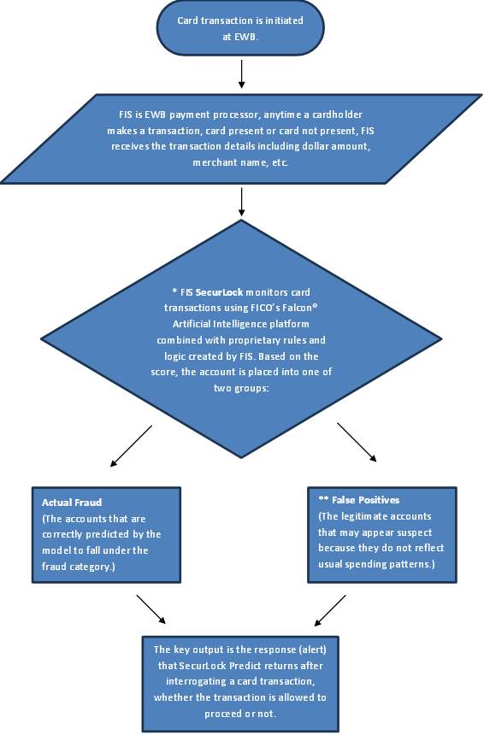

**\*** To calculate FICO Falcon score, the model evaluates data generated from two sources: a current transaction and a card profile. A card profile is a continuously updated history of the card associated with a given transaction.

The higher the score, the greater the likelihood is that the account associated with the transaction has been used fraudulently.

**\*\***The false-positive rate is the percentage of legitimate transactions that a model scores above the threshold. It is referred to as the Percent Non-Fraud.

Example = 100 Not Fraud (VALID)/ 30 Confirmed Frauds (FRAUD) = 3.3 FPR (False Positive Ratio) – EWB decline around 3 valid cardholders to capture 1 fraud account.

FIS and EWB create rules together wherethe card rules are managed by the FIS Risk Office, and EWB monitors rule performance and asks for recommendations of rule changes based on the patterns we are observing.

FIS and EWB look at what is confirmed fraud and make rules around the data and tagging that is observed. EWB adds certain criteria that it deems are necessary based on that fraud to prevent future losses. Tagging provides the core insight for evaluating how well the model is catching fraud.

SecurLock Predict risk office (FIS) is staying current on recent card related fraud threats and updating the rules/logic accordingly.

**The following actions may be taken on a fraud alert generated by FIS SecurLock:**

1. A temporary block can be placed on the card to protect the cardholder and then cardholder contact is initiated.
2. Cardholder contact is initiated and then a temporary block is added.
3. An authorization may be Real Time declined.
4. An Email may be generated to the cardholder if there is a valid email address on file.
5. A call may be placed to the number on file, IFwe have not sent a text to a valid mobile number only.
6. Updates of No Fraud or Confirmed Fraud can be performed within 7 days of the alert creation. After that the issuer will want to take any necessary actions like blocking fraud or removing a temporary block. The issuer can also verify the contact information on file and remind the cardholder of our verification process for future alerts.
7. The account will be permanently blocked as Lost/Stolen if the cardholder is contacted and has confirmed that the activity is fraudulent.

## 1.3 Model Key Stakeholders, Change Management, & Outstanding Issues

Describe, at minimum, the following:

1. Model output key stakeholders, review committee(s).
2. High level summary of model changes in recent time or since last model validation.
3. High level summary of the latest model related business area audit and regulatory exam results including any outstanding findings, regulatory Matter Requiring Attention (MRAs), and management self-identified issues.

Please ensure that **all of** the points mentioned above are addressed.

Model Owner:

1. The key roles and responsibilities as they pertain to the SecurLock model are as follows:

**Model Owner**

* Enterprise Risk Management (ERM): Lead and coordinate with Fraud Strategy Team to implement framework, including performance monitoring and reporting and corrective measures based on MRM findings.

**Model User (Fraud Strategy Team)**

* EWB Fraud Strategy Team: Works with FIS Risk Office to monitor rule performance and ongoing cadence on fraud patterns and changes.

**Model Developer (Vendor)**

* Fidelity Information Services (FIS): East West Bank uses the FIS SecurLock Predict product to run fraud rules on its debit & credit card portfolios.

**Model Validators**

* Bank Model Risk Management determines who the model validators of the SecurLock model will be on a case-by-case basis. Based on each model’s validation requirements, internal resource availability, and subject-matter expertise required, the Bank Model Risk Management may engage outside consulting firms to support a specific validation need.
* Model validators are responsible for completing independent model validation with a scope determined by Model Risk Management’s defined Independent Model Validation Methodology.

**2. Model Changes**

SecurLock Predict was implemented for Credit Card in 2017 and implemented for Debit Card in 2018, both remain operational. Any changes to the model are typically driven by evolving business requirements, regulatory updates or observed performance deviations.

**3. High level summary of Audit and Regulatory Exam Result Model Inherent Risk Rating (IRR):** The preliminary model inherent risk rating (Model-IRR) is assigned as LOW, based on a materiality threshold of less than 5%.

# INPUT DATA INTEGRITY & APPROPRIATENESS

## MODEL DEVELOPMENT DATA

Model Development Data refers to the data used in the research & development process to determine the model specifications. That is, the process for determining the exact mathematical formulas, algorithms, inputs, parameters, and assumptions that comprise a model.

Note: This documentation section is not applicable for those models whose structure is not determined through empirical data analysis. This includes, for example, some market risk / trading models where the model structure is based on financial theory (e.g., Black-Scholes options pricing model) or qualitative models whose structure and parameters were determined judgmentally.

**Reference Document List**

Please list all the documents referred to in this section.

|  |  |  |
| --- | --- | --- |
| **#** | **Reference Document Name** | **High Level Description and purpose of the Document** |
| 1 | f06 MRM-CONTROL01 - y&n Model Assmt Fraud 056 -Charles Lin YesM - SecurLock Predict | Enterprise risk management and Model risk classification procedures. |
| 2 | FICO Falcon Model Governance US Credit v29 (v2.0) | Detailed theory, development, and validation of the FICO® Falcon® Fraud Manager. |
| 3 | FICO Falcon Model Governance US Debit v26 (v2.0) | Detailed theory, development, and validation of the FICO® Falcon® Fraud Manager. |
| 4 | MR_FFM_FP_US_Credit29.0_Falcon6.x | This document shows the relative improvement of the FFM US Credit 29.0 model over the FFM US Credit 28.0 model. |
| 5 | MR_FFM_FP_USDebit26.0_SigPIN_GIP_AA_Falcon6x | This document shows the relative improvement of the FFM US Debit 26.0 model over the FFM US Debit 25.0 model. |
| 6 | SecurLOCK Operations Guide | Operations guide of SecurLock and details of fraud alert generation process. |

**Data Assumptions Summary**

Please list out data assumptions applied in the model development and model production process, such as missing value treatment, outlier treatment, etc.

|  |  |  |  |  |
| --- | --- | --- | --- | --- |
| **#** | **Assumption Name** | **Assumption Description** | **Materiality of Assumption** | **Rationales for this Assumption**  (Business driven or quantitative methodology driven) |
| 1 | Accurate and complete data provision | Clients and processors must be able to provide accurate and complete data for the model execution. | High | This assumption is fundamental because the model’s predictive accuracy and reliability are contingent upon receiving high-quality data.  If data quality or completeness is an issue, then the model will experience sub-optimal performance. |

**Data Limitation Summary**

Please list out data limitations, their impact of business use, and ongoing monitoring program to appropriately manage the related risk.

|  |  |  |  |  |
| --- | --- | --- | --- | --- |
| **#** | **Limitation Name** | **Limitation Description** | **Impact on Business Use** | **Monitoring Description & Frequency** |
| 1 | Data quality sensitivity | In FICO, if data quality or completeness is an issue, then the model will experience sub-optimal performance.  If the data provided by the client fails to meet these assumptions, then the model will experience sub-optimal performance. | Degraded model performance will result in lower account detection rate (ADR), lower real-time value detection rate (RTVDR), and higher than expected false-positive rate (Percent Non-Fraud). | To mitigate risks associated with sub-optimal performance due to data limitations, a robust monitoring framework should be established. Ongoing performance evaluations should assess the impact of data issues on model outputs, ensuring continuous improvements and alignment with operational requirements. |

### Overview of Model Development Data

Provide descriptive characteristics of the model development data, for example, coverage of products / portfolios / transactions, time periods, geographic distribution, etc.

The sources and flows of all the data leveraged in model development should be illustrated with a data flow diagram. The diagram should show each stage of the data preparation process from the initial data pull to the final datasets used for model development and testing including data quality assurance controls.

Model Owner:

**Coverage of Products / Portfolios / Transactions**

The FIS SecurLock Predict model covers a variety of portfolios that are present in EWB. These portfolios include:

* Debit card transactions
* Credit card transactions
* Prepaid card transactions

Time Periods

To capture various fraud patterns and trends for a sustainable period, the data used for model development spans over a couple of years.

Development Data Description

The key input data from an EWB perspective is the card transaction details.

Model variables are included based on their statistical significance and benefit to model performance. FICO performs data validation and go-live analysis to indicate if any fields are not present in the customer's data and/or in error based on its knowledge of the key fields that drive model performance.

The following fields are required for scoring:

* PAN
* authPostFlag
* transactionType
* transactionDate
* transactionTime
* gmtOffsettransactionAmount
* TransactionCurrencyCode

### Development Data Sources, Extraction Process, and Reconciliation



#### 2.1.2.1 Data Sources

Identify the sources of the model development data, for example, internal data from specific corporate data warehouse tables, desktop databases, text files, or external data from third-party vendors or websites. Development data may also include the output of other upstream models or computational tools.

If both internal and external data are used in the model development, you may want to create subsections covering them separately.

Model Owner:

FIS SecurLock Predict follows a rule-based system that utilizes FICO Falcon's transaction scoring capabilities. These scores are utilized by SecurLock to obtain a decision, with its predefined rules acting as the main model processing unit. The risk scores provided by Falcon Fraud Manager are generated by the proprietary neural network technology by FICO while VISA VAA and Mastercard are sourced to trigger alerts for potentially compromised transactions.

To process the transactions and to score them, FICO collects financial data from banks around the world.

The Falcon model evaluates data generated from two sources: current transaction and card profile. Card profile is a continuously updated history of the card associated with a given transaction.

The FICO Falcon Fraud Manger Debit 26.0 and Credit 29.0 model were trained from Falcon Fraud Consortium debit card data and credit card data from issuers in the United States.

#### 2.1.2.2 Data Relevance

Discuss the relevance of the development data to the modeling objective. For example, is the composition of the development data representative of the current portfolio in terms of coverage and distribution of data attributes? Is the time period selected for development data appropriate for the model’s business purpose and the statistical estimation technique?

If proxies for internal data are used, such as internal data for other products or external data from public databases or third-party services, justify and document the applicability and appropriateness of the proxy data to the specific internal portfolio / purpose.

For vendor models, document a comprehensive assessment of the vendor’s development data applicability to the Company’s internal portfolio/products/customers. This typically involves a comparison of the external and internal data for key model drivers (e.g., geographic distribution, loan/transaction size, loan/product type, etc.).

Model Owner:

FIS SecurLock works on a rule-based methodology which uses risk scores as model input generated using FICO Falcon’s neural network technology.

The FICO Falcon Fraud Manager Debit 26.0 and Credit 29.0 models are trained using debit and credit card data from the Falcon Fraud Consortium, sourced from U.S. issuers. The development of these models relies on card transaction details, ensuring the data is highly relevant. This transaction data provides comprehensive, real-time, and actionable insights, enabling the system to accurately and swiftly identify fraudulent activity.

#### 2.1.2.3 Data Extraction Process

Describe how the development data is extracted, either automatically or manually, or otherwise obtained.

Include references to the code or files used to extract the data or to the data files received from other individuals / departments.

Model Owner:

The development data extraction process for FIS SecureLOCK has not been disclosed by the vendor.

#### 2.1.2.4 Data Reconciliation

Demonstrate that the development data has been reconciled with a source system (e.g., the general ledger) or line of business report, or alternatively, explain how the extracted data was determined to be complete and accurate.

In addition, provide a step-by-step waterfall of data counts and balances at every step in the data preparation process from the raw data extract to the final modeling dataset.

Model Owner:

In the context of SecurLock and the FICO model, data reconciliation ensures that modeling data is consistent with production data. This involves validating the presence of required data, ensuring valid values, and checking for completeness. The process includes:

* Continuous cleansing and fixing of raw data based on agreed conditions with the client and modeling team.
* Inventorying the fixed data for the coverage period of a model build.
* Preparing and checking fraud data for completeness.
* Sampling transaction and demographic data using 100% of fraud accounts and a sample of non-fraud accounts.
* Gathering field-level and other statistics on the sampled data.
* Performing file intersection and integrity checks on the sampled data.
* Handing over the data to the modeling team for final quality and validation.

Ethos Reports provide specific fraud-related reports, including data extracts, drill-down reporting, and graphs. These reports help in making informed business decisions and monitoring SecurLock services. Enrollment in SecurLock automatically includes Ethos Fraud Basic, which offers reports on real-time declines, confirmed fraud information, blocked cards, and alerts.

### 2.1.3 Development Data Preparation

#### 2.1.3.1 Data Quality and Treatments

Describe the raw data quality and any treatments used to address missing or erroneous values, for example, algorithms applied to impute values.

Document any analysis of data outliers and their impact on model development / outputs. Provide support for the selected approach for treating the outliers (if any).

Model Owner:

FIS SecurLock Predict follows a rule-based system that utilizes FICO Falcon's transaction scoring capabilities. These scores are utilized by SecurLock to obtain a decision, with its predefined rules acting as the main model processing unit. The risk scores provided by Falcon Fraud Manager are generated by the proprietary neural network technology by FICO.

FICO uses various methods to interpolate the value for the missing data for any given observation. FICO utilizes the following methods for missing data: for categorical values FICO may use a 'missing' or 'default' value typically determined using the population frequency distribution. For non-categorical fields FICO model defaults to the population mean value.

The analysis is a systematic review of model performance based on the varying degrees of data quality. Fields are

tested one at a time by randomly blanking out the field for various percentages of the observations. By reviewing

the degradation of model performance for each field and each level of missing data, FICO is able to determine

which fields are most important to performance. In addition to blank-out analysis, model performance impacts

are reviewed for invalid field values to ensure the model robustly handles data discrepancies. For example, FICO

has evaluated model performance degradation after increasing the transaction amount by 10% in 15% of the

transactions, as summarized in the following table:

|  |  |  |
| --- | --- | --- |
| **Model** | **ADR impact (%)** | **RTVDR impact (%)** |
| FFM US Debit v26 - SIG | 1.29% | 2.04% |
| FP US Debit v26 - SIG | 1.08% | 1.90% |
| FFM US Debit v26 - PIN | 0.28% | 1.51% |

All of these tests help FICO support its clients with model performance and data quality inquiries to ensure the

model is appropriate for a client’s portfolio.

In FICO Falcon, during the data build prior to model development, a data quality report (DQR) is produced to validate that the modeling data is consistent with production data. The validation is performed with respect to the presence of required data, valid values, percentage of records with populated values, and appropriate product type and population.

#### 2.1.3.1 Data Filtering and Exclusions

Provide a detailed description of, and justification for, data filtering and significant data exclusions that may potentially introduce model bias. Where a significant number of records is excluded due to data quality or other reasons, to the extent possible, analysis should be performed and documented showing the impact of the filtering rule.

A complete waterfall from the point of raw data extract to the final development/testing data showing the impacts of each exclusion (in terms of the number of records and other key metrics) should be provided.

Model Owner:

FIS SecurLock Predict follows a rule-based system that utilizes FICO Falcon's transaction scoring capabilities. These scores are utilized by SecurLock to obtain a decision, with its predefined rules acting as the main model processing unit. The risk scores provided by Falcon Fraud Manager are generated by the proprietary neural network technology by FICO.

The FICO Falcon model explicitly exclude the following data categories to ensure fairness and compliance with regulatory standards:

Race

Ethnicity/Color

Religion

Gender

Sexual Orientation

Gender Identity/Expression

Marital Status

Familial Status

Age

National Origin

Protected Veteran Status

Disability

Receipt of Public Assistance

#### 2.1.3.3 Data Sampling

Provide details of statistical sampling, if any, performed to create the model development and testing datasets.

Model Owner:

The FIS SecurLock Predict integrates the FICO Falcon platform to enhance its fraud detection and prevention capabilities as FIS leverages the FICO Falcon Fraud product to score transactions.

With respect to FICO Falcon, the training dataset consists of random samples of the US Credit and Debit Consortium data. Samples are appropriately sized to provide a statistically representative sample.

FICO doesn’t publish the sampling for the model; however, it is common to take 100% fraud account

level and 2% non-fraud account level as a starting point in the development of the model. More or less data will

be used based on the requirements of the build, such as wanting to have more non-fraud exemplars for

development of additional FICO model technologies such as Adaptive Analytics and Global Intelligent Profiles.

#### 2.1.3.4 Data Transformations

Provide a description of, and rationale for, operations/calculations on raw data, such as scaling, forming data segments, averaging, or combining data from multiples sources (for example, to calculate charge-off rates) in order to produce model development-ready data.

Describe the composite/derived variables created out of raw data. For example, splines, Weight-of-Evidence transformations of variables, interaction terms, etc. Provide support for the technical soundness and appropriateness of the selected transformations in the context of the specific modeling approach you selected and the overall model purpose.

Specifically:

For models that utilize feature engineering, provide detailed documentation of the engineering process, including a description of the software/package used to perform the feature engineering and a discussion on the limitations of the selected engineering approach.

For models that utilize unstructured data, include detailed description of the data pre-processing of unstructured data. Provide analysis/test/comparison results with related data/scripts/outputs if any to justify the pre-processing performed.

For advanced machine learning models, also include detailed discussion on the sufficiency and appropriateness of data transformations and treatments applied with respect to the ML algorithm used (for example, standardization/normalization is required for KNN but not for Random Forests). Provide analysis/test/comparison results with related data/scripts/outputs if any to support the discussion.

Model Owner:

FIS SecurLock Predict follows a rule-based system that utilizes FICO Falcon's transaction scoring capabilities. These scores are utilized by SecurLock to obtain a decision, with its predefined rules acting as the main model processing unit. The risk scores provided by Falcon Fraud Manager are generated by the proprietary neural network technology by FICO.

As the data is acquired by FICO Falcon in that context, In production the weights are fixed and unchanged; this continues to drive the highest performance and is most computationally efficient. The model structure is often single layer with different model segments to minimize the amount of degrees of freedom.

The following diagram is a high-level representation of a neural network with a single hidden layer and with the

back propagation of the error. Training typically starts with random weights using back propagation of the errors

to adjust the weights until the network converges.





***Missing Value Handling***

Assuming the data in question are required for model scoring, FICO uses various methods to interpolate the value for the missing data for any given observation. FICO utilizes the following methods for missing data: for categorical values FICO may use a 'missing' or 'default' value typically determined using the population frequency distribution. For non-categorical fields FICO models often default to the population mean value.

Raw data is continuously cleansed and fixed based on previously agreed conditions with the client and modeling team. Once cleansed, the data undergoes the following process:

* The fixed data is inventoried for the coverage period for a particular model build.
* Fraud data for the coverage period is prepared first and checked for completeness.
* The transaction and demographic data are sampled using 100% of the fraud accounts in the fraud file and a sample of the non-fraud accounts.
* Field level and other statistics are gathered on the sampled data.
* File intersection and integrity checks are performed on the sampled data.
* The data is handed over to the modeling team for final quality and validation.

#### 2.1.3.5 Variable Definitions

Provide definitions of variables, including alternative transformations of variables tested. For vendor models, describe how the vendor’s definitions for inputs and outputs compare with the Bank’s internal definitions (e.g., delinquency, defaults, accounting losses, etc.).

Reference the location of the comprehensive data dictionary that lists each variable’s description, source, allowable values, and other relevant information.

Response Variable

Describe the response/performance/dependent variable that the model is designed to estimate/project.

Model Owner:

The response variable that SecurLock Predict is designed for is to estimate whether the transaction is allowed to proceed or not.

Explanatory Variables

Describe the explanatory/independent variable candidates assessed in the model development process.

Model Owner:

Input variables can be referred to as explanatory variables in a model development process, as they are the features or predictors used to explain variations in the target variable (dependent variable).The explanatory variables are the factors used to predict the likelihood of fraudulent transactions. These variables help the model identify patterns and anomalies that indicate potential fraud. Some key explanatory variables in the SecurLOCK Predict model include:

1. **Transaction Amount**: The value of the transaction can be a significant indicator, as an unusual amount may trigger suspicion.
2. **Transaction Location**: The geographical location where the transaction occurs is analyzed, especially if it deviates from the cardholder's usual locations.
3. **Time of Transaction**: The time at which a transaction is made can be crucial, with transactions occurring at odd hours potentially raising red flags.
4. **Merchant Category**: The type of merchant where the transaction takes place is considered, as certain categories may have higher fraud risks.
5. **Device Information**: Data about the device used for the transaction, this information can help identify suspicious activities.
6. **Previous Fraud Incidents**: Historical data on past fraud incidents involving the cardholder or similar transactions are used to enhance detection accuracy.

The key input data from an EWB perspective is the card transaction details. Since FIS is the payment processor, anytime a cardholder makes a transaction, card present or card not present, FIS receives the transaction details including dollar amount, merchant name, etc.

### 2.1.4 Data Limitations

Provide information about known data limitations / weaknesses and an assessment of their impact on the final model’s output. For example, if the model was developed based on external data that differs notably from the Bank’s data, the differences and their potential impact must be documented. For each noted weakness / limitation, describe how the associated risk is currently being mitigated. Additionally, where longer-term remedial actions are being undertaken or planned (e.g., an initiative to clean up the existing data or collect incremental data), such actions should also be documented.

Model Owner:

**Data Limitation**

If data quality or completeness is compromised, the model will experience sub-optimal performance. This can occur due to various factors such as missing data, inaccurate data, or inconsistencies in the data. When the data fed into the model is not reliable, the scores generated by FICO Falcon may be less accurate, leading to potential issues in decision-making processes by SecurLock.

**Impact on business use**

Degraded model performance can result in a lower Account Detection Rate (ADR), meaning fewer fraudulent accounts are identified. Additionally, the Real-Time Value Detection Rate (RTVDR) may decrease, reducing the model's ability to detect fraudulent transactions in real-time. There could be an increased likelihood of a higher-than-expected false-positive rate, where legitimate transactions are incorrectly flagged as fraudulent. These issues can undermine the effectiveness of the fraud detection system, leading to potential financial losses and customer dissatisfaction.

### 2.1.5 Data Preparation Software / Platform

Provide information on the software and/or programming language used in the data extraction, transformation, and other steps to prepare the model development and testing data. Provide a reference to the location of the development programming codes, associated log files, and other data preparation artifacts.

Model Owner:

Information on the software and/or programming language is not provided as they are proprietary in nature, given that this is a vendor model.

### 2.1.6 Data Retention

Describe where the development data is stored (post development) and how the environment is controlled. Provide the minimum time period for data retention.

Model Owner:

Information regarding data retention period is not available.

# 3. CONCEPTUAL SOUNDNESS

## 3.1 MODEL THEORY AND ASSUMPTIONS

**Reference Document List**

Please list all the documents referred to in this section.

|  |  |  |
| --- | --- | --- |
| **#** | **Reference Document Name** | **High Level Description and purpose of the Document** |
| 1 | f06 MRM-CONTROL01 - y&n Model Assmt Fraud 056 -Charles Lin YesM - SecurLock Predict | Enterprise risk management and Model risk classification procedures. |
| 2 | FICO Falcon Model Governance US Credit v29 (v2.0) | Detailed theory, development, and validation of the FICO® Falcon® Fraud Manager. |
| 3 | FICO Falcon Model Governance US Debit v26 (v2.0) | Detailed theory, development, and validation of the FICO® Falcon® Fraud Manager. |
| 4 | MR_FFM_FP_US_Credit29.0_Falcon6.x | This document shows the relative improvement of the FFM US Credit 29.0 model over the FFM US Credit 28.0 model. |
| 5 | MR_FFM_FP_USDebit26.0_SigPIN_GIP_AA_Falcon6x | This document shows the relative improvement of the FFM US Debit 26.0 model over the FFM US Debit 25.0 model. |
| 6 | EWB - Falcon Rules | This document covers SecurLock Predict ruleset. |
| 7 | SecurLOCK Operations Guide | Operations guide of SecurLock and details of fraud alert generation process. |
| 8 | SecurLOCK User Guide 2024 | Users Guide of SecurLock and details of SecurLock servicing. |

**Model Assumption Summary**

Please list out model methodology assumptions applied in the model development and model production process, such as missing value treatment, outlier treatment, etc.

|  |  |  |  |  |
| --- | --- | --- | --- | --- |
| **#** | **Assumption Name** | **Assumption Description** | **Materiality of Assumption** | **Rationales for this Assumption**  (Business driven or quantitative methodology driven) |
| 1 | Continuous updates and adaptation to fraud threats. | SecurLock Predict risk office (FIS) is staying current on recent card related fraud threats and updating the rules/logic accordingly. | High | FIS SecurLock relies on adaptive analytics and real-time decision-making, which depends on current fraud trends. Financial institutions face evolving threats from sophisticated fraudsters who continuously modify their tactics. |
| 2 | Accurate and complete data provision by clients and processors. | Clients and processors must be able to provide accurate and complete data to the model execution. | High | Inaccurate or missing data can result in incorrect predictions, either failing to flag a fraudulent transaction or incorrectly flagging legitimate ones. This could undermine the performance of fraud detection strategies and lead to financial losses. |

**Model Limitation Summary**

Please list out model methodology related limitations, their impact of business use, and ongoing monitoring program to appropriately manage the associated risk.

|  |  |  |  |  |
| --- | --- | --- | --- | --- |
| **#** | **Limitation Name** | **Limitation Description** | **Impact on Business Use** | **Monitoring Description & Frequency** |
| 1 | Population and portfolio consistency limitation. | The model should be applied only to the population of product types, geography, and transaction types on which the model was developed. There should be no significant change to the portfolio(s) and the statistics on the production data sent to the model must be stable. | **Limited Applicability**: The model is tailored for specific product types, geographies, and transaction types. Applying the model to other segments can lead to unreliable results, as it may not capture the unique characteristics or risks associated with those segments.  **Performance Degradation:** Significant changes to the product portfolio or transaction types could cause the model's predictive accuracy to decline, potentially leading to false positives or missed fraud cases. | If discrepancies are observed, further analysis should be performed to assess the impact on model performance, and corrective actions should be considered. |

### Model Theory and Methodology

#### 3.1.1.1 Modeling Approach

Provide a description of the modeling approach you have selected, including the statistical estimation approach or machine learning technique, if applicable (with further details of the model construction/estimation process to be provided in Section 3.2 Model Estimation/Training and Selection).

For advanced Machine Learning (ML) models, discuss briefly whether a self-explanatory or less complex model (e.g., logistic regression, linear regression) is viable in solving the same business problem. If not, explain why not. Detailed information on this topic should be provided in Section 3.1.1.3. Alternative Approaches Explored

Model Owner:

**SecurLOCK** transactional monitoring will monitor card transactions using FICO’s Falcon® Artificial Intelligence platform combined with proprietary rules and logic created by FIS to maximize fraud mitigation.

FICO utilizes a proprietary neural net technology called NNET08 for credit card monitoring and NNET20 for debit card monitoring which is a tool utilizing back propagation and unique regularization to produce a neural net score that is refined for rare event detection such as payment card fraud. This NNET08 and NNET20 has been shown repeatedly to outperform other neural net trainers on the market and even FICO's own Model Builder.

Beyond Neural Network models, FICO scientists have studied Logistic Regression, Support Vector Machines (SVM), Genetic Algorithms (GA), and many bagging and boosting learning algorithms in building Ensemble models. These alternative techniques have been found to be impractical in fraud detection due to excessive training time and computational cost. Many of those modeling techniques are computationally expensive to score transactions in real-time when compared to Neural Network models.

#### 3.1.1.2 Model Structure/Formulae

*Detail all relevant mathematical equations applied in the model with a clear explanation of the notation*. Describe the model inputs and outputs if not already provided in Section 2.1.3.5. Variable Definitions

Note: This section applies to all models and should be especially detailed for models that were not developed through statistical or machine learning analysis of empirical data (e.g., the market risk / trading models based on financial theory). For these models, the rationale for the particular choice of inputs (e.g., prices, interest rates, volatilities, variance/covariance matrices) should be provided.

Model Owner:

FICO utilizes a proprietary neural net technology called NNET08 for credit card monitoring and NNET20 for debit card monitoring which is a tool utilizing back propagation and unique regularization to produce a neural net score that is refined for rare event detection such as payment card fraud.

In production the weights are fixed and unchanged; this continues to give the highest performance and is most computationally efficient. The model structure is often a single layer with different model segments to minimize the number of degrees of freedom.

The following diagram is a high-level representation of a neural network with a single hidden layer and with the back propagation of the error. Training typically starts with random weights using back propagation of the errors to adjust the weights until the network converges.

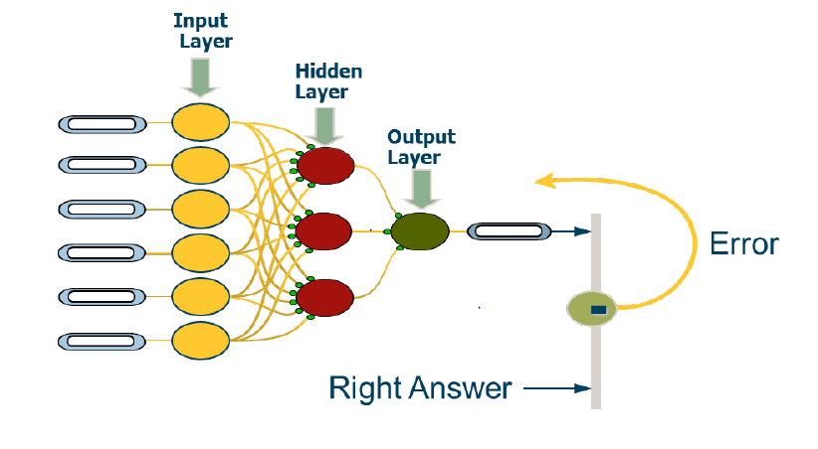

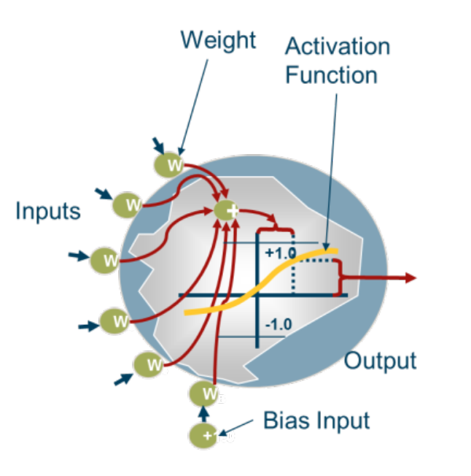

#### 3.1.1.3 Alternative Approaches Explored

Describe how the selected model theory/methodology (and estimation technique, if applicable) compares with industry practices for similar models and provide rigorous support for a selected approach that is non-standard or innovative. Provide references to industry and academic publications supporting the choice of this modeling methodology.

Describe alternative modeling approaches (including alternative estimation/numerical techniques, if applicable) that were considered and why they were not selected. Provide references to industry and academic publications discussing the alternative methodologies.

For machine learning (ML) models, provide performance comparison between the self-explanatory model and the selected ML model and a discussion on the trade-offs between model performance and transparency/interpretability. If a self-explanatory model is viable, also provide analysis/test/comparison results with related data/scripts/outputs if any to support the discussion.

Provide a comparative narrative for the selected ML model vs. other comparable/state-of-the-art methodologies with a discussion on the advantages and disadvantages of the selected ML model vs. the alternatives.

Model Owner:

The FICO Fraud Analytics team is committed to model evolution and innovation having applied for more than 110 patents for fraud analytic techniques and receiving approval for over 75 of them.

The team constantly revisits its modeling techniques, bringing in new modeling components and technologies into Falcon models. Over the years, many data mining and machine learning techniques have been extensively explored in consortium model builds. FICO modeling has focused on two main modeling categories, the unsupervised/semi-supervised solutions and more sophisticated supervised modeling solutions.

The unsupervised/semi-supervised modeling includes outlier detection, Principal Component Analysis (PCA), and self-calibrating models. This solution is mostly targeted at emerging markets, where data availability is an issue and fraud tagging are not accurate. Therefore, data is insufficient to build a supervised model, and self-calibrating technology is used in building an outlier model relying on learning outlier values in real-time. Generally, the implementation of the outlier detection models is efficient, but the model performance is lower than the supervised model such as a Neural Network.

FICO’s supervised models are built on unrivaled data consortiums. FICO collects financial data from banks around the world. With well-designed data specifications, FICO collects rich transactions and fraud information that provides great value in fraud detection. Beyond Neural Network models, FICO scientists have studied Logistic Regression, Support Vector Machines (SVM), Genetic Algorithms (GA), and many bagging and boosting learning algorithms in building Ensemble models. These alternative techniques have been found to be impractical in fraud detection due to excessive training time and computational cost (CPU and memory usage). Many of those modeling techniques are computationally expensive to score transactions in real-time when compared to Neural Network models.

Falcon models use Neural Networks because of their high performance and efficiency in processing transactions in real-time. The seamless integration with the Falcon software makes it highly efficient to provide real-time solutions for our consortium members.

A Neural Network model was compared with a Random Forest model by FICO. It was observed that the Neural Network model performed better.

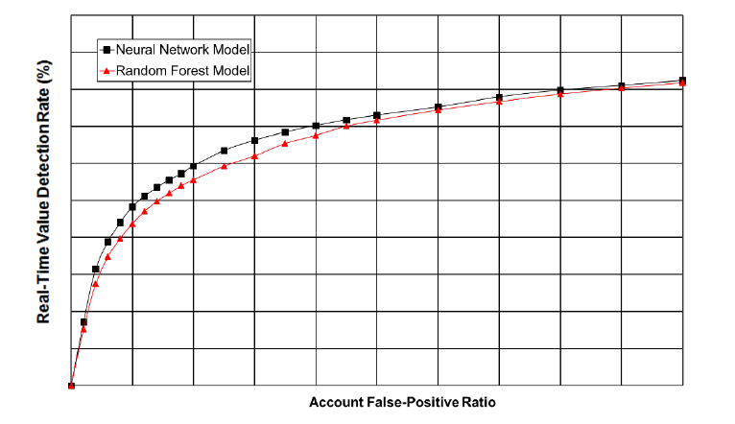

FICO compared Neural Networks model with a logistic regression model. While comparing the two models, it was observed that there were significant performance gains using Neural Networks.

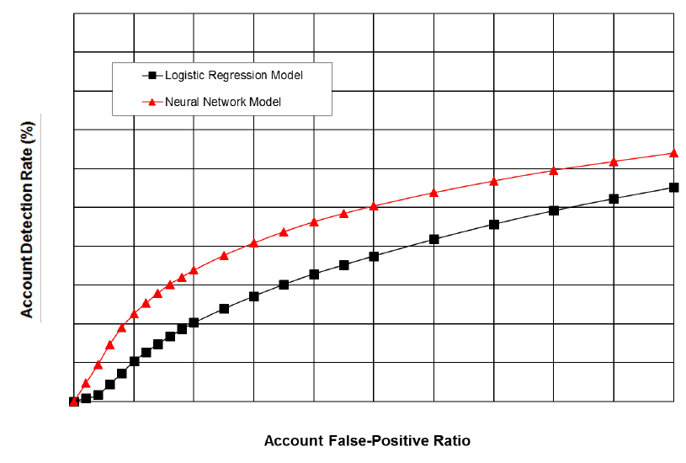

### Segmentation Approach

Describe and justify the selected model segmentation scheme (or lack thereof), including any related quantitative analyses performed and subject matter expert qualitative considerations. Provide the segmentation waterfall logic, if applicable. Assess the impact of the selected segmentation scheme on the model estimation and output.

If in-model segmentation approach was followed (rather than developing separate equations/model objects for each segment), explain this with the rationale for going the route of in-model segmentation.

Model Owner:

The segmentation approach for SecurLock using FICO scores focuses on differentiating transaction risk across credit and debit card portfolios in EWB. For credit cards, it assesses card-present and card-not-present transactions, incorporating factors like merchant name, transaction amount. For debit cards, segmentation includes signature-based (card-present and not-present) and PIN transactions, leveraging FICO scores to enhance fraud detection by identifying high-risk patterns across these categories.

Card Present (CP) transaction – use a physical payment card at point of sale (POS) terminal, or other in person transaction setting.

Card Not Present (CNP) transaction - makes transactions without physically possessing the card, typical in e-commerce, or phone.

### Model Settings

If applicable, describe model settings and parameters, including vendor model customizations. For example, a vendor model may offer alternative interest rate term structures for valuation purposes. or a vendor may recommend updated model tuning parameters (e.g., for mortgage prepayment models) to be used in place of default values. For each setting/parameter, justify the selected value relative to the other choices available.

Model Owner:

Falcon models run on neural-network models that calculate a score each time they are presented with a card transaction. Scores range from 1 to 999. The higher the score, the greater the likelihood is that the account associated with the transaction has been used fraudulently.

To use a Falcon model, an issuer sets a threshold score. If a transaction on an account score is above this threshold, it is considered suspect enough to be investigated further or referred. Scores above the threshold place the transaction, and thus an account, into one of two groups: actual frauds or false positives; the latter are legitimate accounts that may appear suspected because they do not reflect usual spending patterns.

For more information related to SecurLock Predict ruleset, please refer to **“EWB - Falcon Rules”**.

### Model Assumptions

List and justify the implicit and explicit assumptions associated with the model, including qualitative or quantitative expert judgments. Assess the impact of each assumption to the extent possible. For example, if a model relies on an average of historical values over the last 6 months, it may be important to test the impact on the model output of selecting alternative assumptions, e.g., 3 months, 9 months, etc.

If any assumptions are intended to be conservative, explain in what way they are conservative.

NOTE: Testing of any technical assumptions underlying the selected statistical/machine learning technique should be documented in Section 3.3.1. Statistical and Technical Assumptions Testing.

Model Owner:

• Assumption:

**SecurLock Predict risk office (FIS) is staying current on recent card related fraud threats and updating the rules/logic accordingly.**

Materiality of assumption:

The materiality is high because the accuracy and reliability of fraud detection models directly impact financial loss mitigation and customer trust.

Rationale for this assumption:

FIS SecurLock relies on adaptive analytics and real-time decision-making, which depends on current fraud trends. Financial institutions face evolving threats from sophisticated fraudsters who continuously modify their tactics.

• Assumption:

**Clients and processors must be able to provide accurate and complete data to the model execution.**

Materiality of the assumption:

Materiality is high, as quality of the data provided to the model directly impacts the accuracy and effectiveness of the fraud detection process. If the data is incomplete or inaccurate, the model may fail to identify fraudulent transactions, leading to higher fraud risks or false positives.

Rationale for this assumption:

Inaccurate or missing data can result in incorrect predictions, either failing to flag a fraudulent transaction or incorrectly flagging legitimate ones. This could undermine the performance of fraud detection strategies and lead to financial losses.

### Model Limitations and Weaknesses

List any known model limitations and weaknesses. For each weakness / limitation, there should be a description of the associated model risk and, if applicable, the risk mitigant designed to address this risk. See the following example:

| ***Model Weakness or Limitation*** | ***Associated Model Risk(s)*** | ***Model Risk Mitigants / Remediation*** |
| --- | --- | --- |
| The model output is heavily impacted by several judgmental management assumptions, including x, y, and z. These assumptions are currently lacking empirical support. | Use of judgmental assumptions increases the risk of poor model predictions / measurements and unsupported model estimates, which may lead to inappropriate business decisions. | **Short Term Risk Mitigants**:   1. The judgmental assumptions will be subject to oversight by the governance committee X that will review and challenge the model owner's support for the assumptions on a monthly basis. 2. The model output will be benchmarked to the output from the alternative model Y on a quarterly basis. Significant divergence in the outputs will be investigated.   **Longer Term Remediation Plan**:   1. The model owner will investigate the possibility of obtaining empirical support for the assumptions x and y once an additional 6 months of data are collected. 2. The model owner will investigate the possibility of modifying the modeling approach to reduce the reliance on judgmental assumptions. |

Model Owner:

|  |  |  |
| --- | --- | --- |
| ***Model Weakness or Limitation*** | ***Associated Model Risk(s)*** | ***Model Risk Mitigants / Remediation*** |
| There may be a limitation in terms of the amount of consortium data/data sources being levered by SecurLock Predict. | Reduced Accuracy: Limited consortium data or data sources may result in a narrow view of fraud patterns, reducing the model's ability to generalize effectively to emerging or rare fraud schemes.  Overfitting Local Data: The model may overly rely on institution-specific data, making it less effective in detecting global or novel fraud trends. | Strengthen the feedback loop with Falcon to continuously improve fraud pattern detection by incorporating its global fraud insights. |
| The model should be applied only to the population of product types, geography, and transaction types on which the model was developed. There should be no significant change to the portfolio(s) and the statistics on the production data sent to the model must be stable. | The model may underperform or produce inaccurate results if applied to data outside its training scope (e.g., new geographies, product types, or transaction types).  Portfolio Drift Risk:  Changes in portfolio characteristics (e.g., shift in customer demographics, transaction patterns) may lead to reduced model accuracy and higher false positives or negatives. | Regularly review the population characteristics (product types, geographies, and transaction types) to ensure alignment with the training data.  Implement a portfolio drift monitoring framework to track changes in customer demographics, transaction behaviors, and other key features over time. |

## MODEL ESTIMATION / TRAINING AND SELECTION

Note: “Model estimation/training” is mostly applicable for those models that rely on statistical estimation and optimization techniques, such as regression analysis or machine learning techniques. However, this section is also relevant to some other types of models, including those that are developed using expert judgment (qualitative models).

**Reference Document List**

Please list all the documents referred to in this section.

|  |  |  |
| --- | --- | --- |
| **#** | **Reference Document Name** | **High Level Description and purpose of the Document** |
| 1 | f06 MRM-CONTROL01 - y&n Model Assmt Fraud 056 -Charles Lin YesM - SecurLock Predict | Enterprise risk management and Model risk classification procedures. |
| 2 | FICO Falcon Model Governance US Credit v29 (v2.0) | Detailed theory, development, and validation of the FICO® Falcon® Fraud Manager. |
| 3 | FICO Falcon Model Governance US Debit v26 (v2.0) | Detailed theory, development, and validation of the FICO® Falcon® Fraud Manager. |
| 4 | MR_FFM_FP_US_Credit29.0_Falcon6.x | This document shows the relative improvement of the FFM US Credit 29.0 model over the FFM US Credit 28.0 model. |
| 5 | MR_FFM_FP_USDebit26.0_SigPIN_GIP_AA_Falcon6x | This document shows the relative improvement of the FFM US Debit 26.0 model over the FFM US Debit 25.0 model. |
| 6 | SecurLOCK Operations Guide | Operations guide of SecurLock and details of fraud alert generation process. |
| 7 | SecurLOCK User Guide 2024 | Users Guide of SecurLock and details of SecurLock servicing. |

### Estimation Methodology and Assumptions

Describe in detail the model estimation methodology, including the assumptions that may be implicit in the estimation technique. For example, ordinary least squares estimations include assumptions about regression residuals. Describe any expert judgments related to the estimation, such as the selection of variable weighting methodologies.

For machine learning (ML) models, discuss whether monotonicity of relationships between the model features and the target variable is important or required, and whether the ML algorithm is configured to ensure such monotonicity.

Model Owner:

FICO utilizes a proprietary neural net technology called NNET08 for credit card monitoring and NNET20 for debit card monitoring which is a tool utilizing back propagation and unique regularization to produce a neural net score that is refined for rare event detection such as payment card fraud.

This NNET08 has been shown repeatedly to outperform other neural net trainers on the market and even FICO's own Model Builder. In production the weights are fixed and unchanged; this continues to give the highest performance and is most computationally efficient. The model structure is often single layer with different model segments to minimize the number of degrees of freedom.

The following diagram is a high-level representation of a neural network with a single hidden layer and with the back propagation of the error. Training typically starts with random weights using back propagation of the errors to adjust the weights until the network converges.



While specific proprietary details about NNET08 and NNET20 are limited, general assumptions applicable to neural networks include:

• The input data is accurately labeled, clean, and preprocessed to remove noise and inconsistencies.

• The selected features (e.g., transaction amount, location, time) are relevant and have predictive power for detecting fraudulent activities.

• The training data distribution is representative of the real-world scenarios the model will encounter, including the proportion of fraudulent to non-fraudulent transactions.

• The neural network's architecture, including the number of layers and neurons, is appropriately complex for the problem, with regularization techniques applied to prevent overfitting.

• The training process is stable, with appropriate learning rates and convergence criteria, ensuring the model reaches an optimal solution.

• The model's outputs are interpretable, and certain features exhibit monotonic relationships with the prediction outcome, enhancing trust and compliance with regulatory standards.



### Modeling Software / Platform

Provide information on the software and/or programming language used in the model estimation/training (including the version number, if applicable). If relevant, list the specific algorithms and packages used in model training.

Model Owner:

The FIS SecurLock Predict model follows a rule-based decision approach as a fraud detection framework. This framework of the model is supplemented with FICO Falcon Fraud Manager, which provides transactional risk scores for further processing.

Since FIS SecurLock Predict is a rule-based model, there isn’t any modeling software that is utilized. The fraud detection process is based on a set of predefined rules, that are applied over the risk score generated by FICO Falcon Fraud Manager.

As for FICO Falcon Fraud Manager, the modeling software involves a combination of their proprietary FICO technology. This proprietary FICO technology combines statistical and machine learning libraries, real-time data processing platforms, along with a cloud-based infrastructure.

### Hyper-parameter Tuning

For machine learning models, include a detailed description of the hyper-parameter tuning process, including the following information:

* The approach used for hyper-parameter tuning, including the rationale for leveraging this approach.
* The list of the hyper-parameters tuned (as well as those that are left at default values) and the range of values searched. If applicable, explain why some hyper-parameters were not tuned.
* Performance metric(s) used to select the optimal hyper-parameters and the supporting rationale.
* Sufficiently detailed discussion of the results of the tuning process and selected values, including any judgmental adjustments to the parameters, if any.

If the model also utilizes pre-training during development, provide details of the pre-training process and the pre-trained model as well as related analysis/test/comparison results.

Model Owner:

The training process involves weight initialization and backpropagation-based optimization, which are key components that could be adjusted during tuning to optimize FICO Falcon model performance.

**Training Process:** Training starts with random weights, with back propagation of errors used to adjust the weights until the network converges.

**Model Structure:** The model is typically a single layer, segmented into different parts to represent varying degrees of freedom.

**Production Deployment:** In production, once the optimal weights are determined, they are fixed and remain unchanged to give the highest performance.

The hyperparameter tuning focuses on optimizing the initial weight configuration, regularization parameters, and segmentation of the single-layer structure to achieve convergence and maximize detection performance in rare event scenarios.

Apart from these, no additional hyperparameter tuning is applied, as the model primarily relies on the structured architecture of the FICO Falcon framework for its fraud detection capabilities. The focus remains on ensuring that weight updates and error propagation are optimized to improve fraud classification accuracy.

### Feature / Variable Selection

Describe in detail the approaches used to select candidate and final model variables/features, including the relevant criteria/thresholds for quantitative selection criteria, as well as any expert judgments.

Describe the process for involving subject matter specialists from the line of business to obtain their views on candidate variables, including the associated economic theory/business intuition behind each variable, as well as the expectation for the directional impact of each variable on the model output.

Describe any algorithms or statistical procedures (such as correlation analysis, Information Value analysis, stepwise regression procedure, etc.) used as part of the process to select final model variables from the full set of candidate model variables.

Model Owner:

During model retrain, FICO takes a “kitchen sink” approach to variable selection. Standard statistical techniques such as stepwise, forward, and backward analysis as well as internally developed methodologies are used in variable selection. Variables that are no longer predictive from the prior model version are removed and additional variables are considered.

### Model Estimation / Training Results

**For statistical models,** provide statistical estimation results for the final model, as well as other model structures that were considered to be strong candidates. Estimation results should include not only the estimated coefficients, but also the t-statistics and associated p-values, measures of model fit, and summary of results of the appropriate statistical diagnostic tests (detailed statistical testing should be documented in the Statistical Testing section).

In addition to providing the estimation results, explain why this model was selected (relative to other candidate models), including both quantitative and qualitative factors.

**For machine learning models:**

* Provide a listing of the full set of features included in the final model.
* Provide a feature importance chart showing the top X most important features in the final model.
* Provide information on the number of features that contribute 90%, 95%, and 99% of model fit. If the number of features providing the last 1-2% of model fit is significant, explain the rationale for their inclusion.

**For both statistical and machine learning models**, this section should contain for each feature an explanation of the economic theory/business intuition for the inclusion of this feature, as well as the assessment of the estimated directionality of the relationship between the feature and the target variable relative to the a priori expectations. For simple statistical models this assessment can be accomplished through the evaluation of the estimated coefficient signs. For complex statistical and machine learning models, use of explainability testing techniques is required (refer to Section 3.3.5 Model Explainability Testing).

Model Owner:

**Model Data Inputs**

These data elements may be used separately or to create derived variables for the model. Model variables are included based on their statistical significance and benefit to model performance. FICO performs data validation and go-live analysis to indicate if any fields are not present in the customer's data and/or in error based on its knowledge of the key fields that drive model performance.

**Variable Selection**

* **Approach**: During model retrain, FICO takes a “kitchen sink” approach to variable selection.
* **Techniques Used**: Standard statistical techniques such as stepwise, forward, and backward analysis, as well as internally developed methodologies, are used in variable selection.
* **Variable Updates**: Variables that are no longer predictive from the prior model version are removed, and additional variables are considered.

**Model Comparison and Selection**

* **Alternative Techniques**: Beyond Neural Network models, FICO scientists have studied Logistic Regression, Support Vector Machines (SVM), Genetic Algorithms (GA), and many bagging and boosting learning algorithms in building Ensemble models.
* **Practical Considerations**: These alternative techniques have been found to be impractical in fraud detection due to excessive training time and computational cost. Many of those modeling techniques are computationally expensive to score transactions in real-time when compared to Neural Network models.

**Model Performance Metrics**

#### Judgmental Adjustments

Describe and justify any judgmental overlays/overrides of statistically estimated input parameters. If any such adjustments are intended to be conservative, explain in what way they are conservative. Note: this section should not be used to detail any overlays/overrides to the model outputs (described in Section 3.3.11. Need for Model Overlays).

Model Owner:

Currently there are no judgement overlays and overrides by the model owner/user. If judgmental adjustments are required, it will be driven based on the ongoing fraud risk assessment in response to significant risks to the bank.

### Other Types of Model Estimation

#### Model Calibration

If applicable, describe the calibration process for models that are regularly fit to market data.

Model Owner:

In SecurLock, business rules are used that require optimization or calibration to fine tune performance on an ongoing basis.

The card rules are managed by the FIS Risk Office, but EWB also monitors rule performance and asks for recommendations of rule changes based on the patterns observed.

Additionally, leveraging additional global profiles that are updated in real-time when risky behavior is detected allows fraud models to adjust quickly to reduce loss. By updating models with greater frequency, new fraud trends can be incorporated as they are identified from around the globe.

#### Vendor Model Tuning

If applicable, describe the process and results for any customization of vendor models (e.g., tuning of vendor model behavioral model parameters to Bank portfolio credit or prepayment experience) that is analogous to a statistical estimation.

Model Owner:

In SecurLock, business rules are used that require optimization or calibration in order to fine tune performance on an ongoing basis.

The FIS SecurLock model, based on the FICO Falcon framework, primarily utilizes vendor-defined configurations for tuning. The model’s optimization is centered on rule and threshold adjustments, which allow fine-tuning of fraud detection parameters to align with varying fraud patterns.

## Model Development Testing

For each test discussed in the following subsections, include the purpose of the test, the testing methodology, the criteria used to evaluate test results (that is, the applicable metrics and thresholds), and a summary of the results with commentary and conclusions. For any anomalous results, the conclusions should include information on the impact of these results on the model outputs and business use, and whether they require any specific risk mitigant.

The level of detail for the testing documentation should be sufficient to provide a clear and definitive basis for the model owner’s conclusions about model’s performance and robustness.

**Reference Document List**

Please list all the documents referred to in this section.

|  |  |  |
| --- | --- | --- |
| **#** | **Reference Document Name** | **High Level Description and purpose of the Document** |
| 1 | f06 MRM-CONTROL01 - y&n Model Assmt Fraud 056 -Charles Lin YesM - SecurLock Predict | This document includes Model vs. Non-Model Assessment Form. |
| 2 | FICO Falcon Model Governance US Credit v29 (v2.0) | Detailed theory, development, and validation of the FICO® Falcon® Fraud Manager. |
| 3 | FICO Falcon Model Governance US Debit v26 (v2.0) | Detailed theory, development, and validation of the FICO® Falcon® Fraud Manager. |
| 4 | MR_FFM_FP_US_Credit29.0_Falcon6.x | This document shows the relative improvement of the FFM US Credit 29.0 model over the FFM US Credit 28.0 model. |
| 5 | MR_FFM_FP_USDebit26.0_SigPIN_GIP_AA_Falcon6x | This document shows the relative improvement of the FFM US Debit 26.0 model over the FFM US Debit 25.0 model. |
| 6 | Visa 2023 U.S. VAA Model Documentation | Visa VAA model Documentation |
| 7 | MRM-CONTROL02 - Model Inherent Risk Rating Assessment Form v04 - FIS SecurLock Predit | This document includes Model Inherent Risk Rating Assessment Form. |
| 8 | DC Metrics | Summary of Debit Card Metrics. |

### Statistical and Technical Assumptions Testing

For statistical and any other models that include statistical and other technical assumptions, provide testing of all assumptions associated with the selected estimation technique (e.g., for Ordinary Least Squares models on time series data this includes testing for multicollinearity, heteroscedasticity, non-normality of errors, autocorrelation, non-stationarity, seasonality, etc.).

For vendor models, to the extent that the assumptions testing information is available from the vendor, include the model owner’s assessment of the testing results and any associated risks.

Model Owner:

As per SecurLock Predict, this is not applicable, as it operates as a rule-based system, following a set of predefined rules. It relies on logical decision-making processes rather than using data-driven patterns and does not require any statistical or technical assumptions.

FIS SecurLock Predict utilizes risk scores derived from FICO Falcon's neural network technology as model inputs.

**FICO Falcon’s Statistical and Technical Assumptions include the following:**

* The client’s portfolio should resemble the statistics of the model development portfolio and should be carefully monitored in terms of score distribution.
* In addition, any client’s portfolio should use the model only on those portfolios that meet the specifications outlined previously with respect to geography, product type, and transaction type.

### Model Performance / Fit Testing

Provide testing of model performance / fit on the estimation and hold-out samples, including calculations of relative and absolute model errors for different population/product/portfolio risk segments and time periods. For some models, their fit can be evaluated using various additional statistical metrics and analytical techniques. This includes, for example: the K-S test, ROC curves (and AUC/Gini coefficient and similar measures of discriminatory power), lift charts, Precision/Recall, F1 score, risk profiling, etc.

For vendor models, include the model owner’s assessment of the model performance/fit testing results provided by vendor (based on vendor’s data) and any associated risks. In addition, include testing results on the Company’s internal data (or explain why it is not feasible).

Model Owner:

Due to insufficient data for comprehensive evaluation, we are unable to fully address this section. However, the model primarily relies on FICO Falcon’s transaction scoring capabilities, which should be considered in assessing its performance and fit testing. Relevant information on FICO Falcon is provided below.

A model is considered to perform well when it achieves high ADR and RTVDR while keeping false positives at an acceptable level.

The Falcon United States Credit 29.0 model offers better account detection rates and real-time value detection rates than the Falcon United States Credit 28.0 model, indicating that it finds more credit-card frauds and finds them faster.

The following figures show ADR and RTVDR versus Percent Non-Fraud for the FFM US Credit 29.0 model and the FFM US Credit 28.0 model. The FFM US Credit 29.0 model provides better detection rates at all false-positive rates.

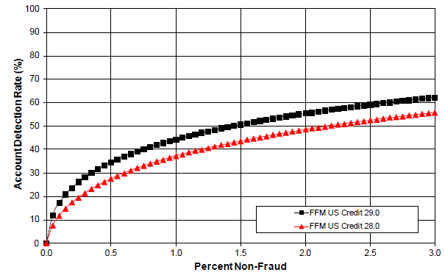

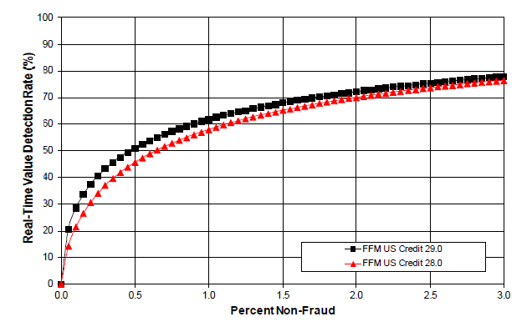

The Falcon United States Debit 26.0 model offers better account detection rates and real time value detection rates than the Falcon United States Debit 25.0 model, indicating that it finds more debit-card frauds and finds them faster.

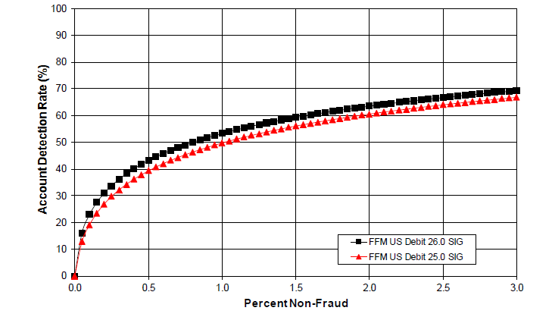

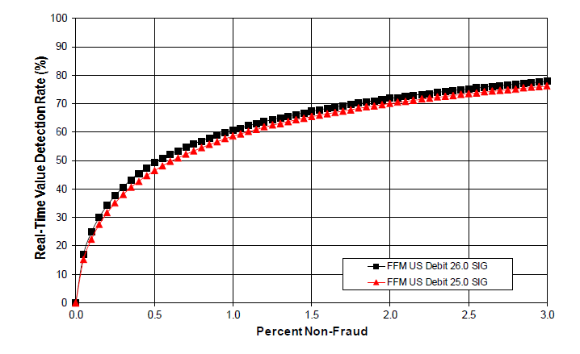

# 

## 

## 

## 

### 

### 

#### **3.3.2.1 In-sample Performance/Fit**

Use this section for the testing of model performance/fit on the data on which the model was estimated/trained.

Model Owner:

The vendor has not disclosed the results of the model performance or fit testing on the data on which the model was estimated or trained. Therefore, we are unable to provide specific findings or insights in this section.

#### **3.3.2.2 Out-of-sample (but not out-of-time)**

Use this section for the testing of model performance/fit on data from the same time period as the in-sample estimation/training data but held out for model testing purposes.

Model Owner:

Out-of-sample (but not out-of-time) performance fit results are not provided as they are computed on data from the same time period as the in-sample estimation/training data, which is proprietary to the vendor.

#### **Out-of-time**

Use this section for the testing of model performance/fit on data from the time period different from the in-sample data, and not used in the estimation either because it was not yet available at the time of model estimation, or because it was available but excluded from the estimation/training for the express purpose of performing out-of-time model fit testing.

Model Owner:

Out-of-time testing is a method used to evaluate the performance of a predictive model by testing it on a dataset that was not used during the model's training phase.

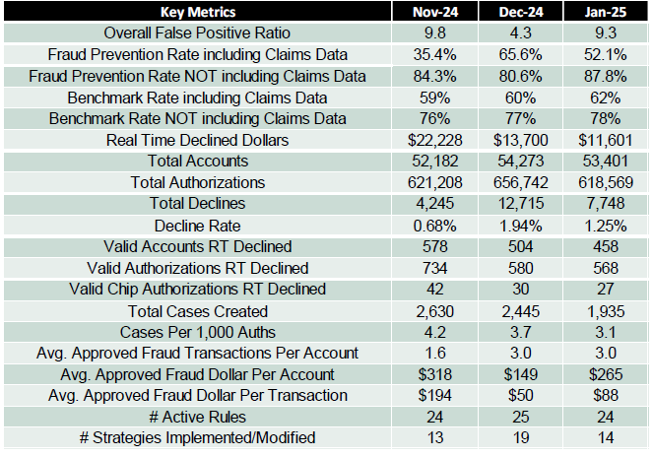

For this analysis, Performance metrics from three consecutive months – November 2024, December 2024 and January 2025 were taken to evaluate the model’s performance. These metrics were used to monitor the model’s ability to correctly identify fraudulent transactions over time and assess any shifts in performance across different periods.

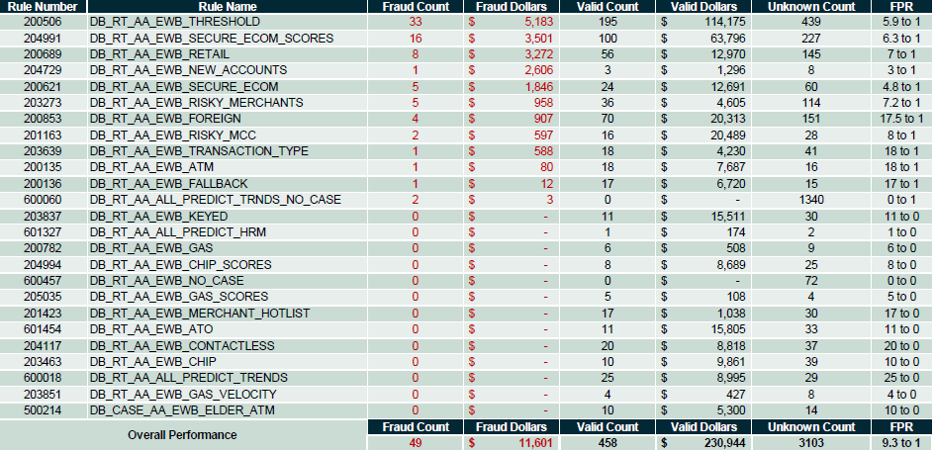

### Model Stability and Overfitting Testing

Provide testing to assess the stability of the model’s estimated relationships, for example:

* For statistical regression models, this involves regression coefficient stability testing and testing for structural breaks. Coefficient stability testing can be performed by repeatedly re-estimating the model on different subsets of the development sample (e.g., random sub-samples or samples representing different time periods covered by the dataset) as well as out-of-sample / out-of-time datasets. Values of regression coefficients and p-values across all samples are then assessed to evaluate the model stability.
* For machine learning models, because a comparison of model parameters is either impossible or impractical, testing of model stability generally involves a comparison of key performance statistics (e.g., K-S, AUC, Precision, Recall, F1, etc.) on different training and testing datasets. A common technique for assessing machine learning model’s stability and evaluating the risk of model overfitting is k-fold analysis. K-fold analysis should be performed in addition to testing of the model on the training, validation, out-of-sample, and out-of-time datasets.

Model Owner:

Not applicable as SecurLock Predict is a rule-based system.

### Back-testing

In addition to the model performance/fit testing documented in Section 3.3.2. Model Performance / Fit Testing, back-testing is highly beneficial and should be performed/documented for certain types of models. Back-testing is a class of testing techniques designed to assess the consistency of model predictions/estimations with the actual observed values, especially for different historical periods and over longer testing horizons.

These tests are designed to measure the accuracy of model performance over specified time periods. When documenting back-testing analyses, it is critically important to provide a detailed description of the test design including, for example:

* The design of the testing dataset includes the description of the time period, and information about any notable exclusions/inclusions that are inconsistent with the data used to develop the model.
* The logic for generating model predictions. For example, when back-testing a mortgage default model, the model developer would typically start with a particular historical portfolio snapshot and then use the model to generate predictions for each subsequent month/quarter without truing the model up using subsequent historical data.
* The source and nature of inputs and assumptions used in the back-test. For example, for a model that uses macroeconomic variables as inputs, the typical practice is to use actual historical values of such inputs during the back-test period (in order to isolate the error of the tested model from the error in the economic forecasts).

Use of graphical presentation of actual and predicted values is necessary in addition to any quantitative measures of model error (e.g., MAPE, MSE, etc.). This allows the model developer and reader to observe any areas of persistent model bias.

The developers should ensure that performance metrics and thresholds for acceptable performance are clearly stated and are aligned with the model’s business use. For example, for stress testing or CECL model designed to produce loss forecasts over a 2-year period, one of the error metrics should be based on the cumulative actual vs. predicted losses over a 2-year back-testing horizon.

Back-testing results should be accompanied by detailed narrative providing the model developers’ assessment of said results and their conclusions about any notable model biases or elevated error rates. Some such notable biases and performance issues may need to be noted as model weaknesses that must have associated risk mitigants.

Back-testing should be carried out for different populations. For example, when analyzing performance of residential or commercial mortgage loans, one should separately evaluate performance of the model on sub-populations that can be reasonably expected to have different behavioral characteristics. For example: different products, different vintages, or different segments of population by FICO score or by LTV or by another key risk driver.

Predictive models should also be back-tested over different economic environments, e.g., periods of stress vs. periods of economic growth. This is especially important for stress testing, CECL, and IFRS 9 models.

For vendor models, include the model owner’s assessment of the back- testing results provided by vendor (based on vendor’s data) and any associated risks. In addition, provide testing results on the Company’s internal data (or explain why it is not feasible).

In-time

Use this section for backtesting using the data from the same time period on which the model was estimated/trained.

Model Owner:

The results of the testing are not provided as they are proprietary in nature, given that this is a vendor model.

Out-of-time

Use this section for backtesting using data from the time period different from the in-sample data.

Model Owner:

The results of the testing are not provided as they are proprietary in nature, given that this is a vendor model.

### Model Explainability Testing

**For machine learning models**, provide sufficient information to understand the drivers of the model outputs and the directionality of their impacts. Use feature importance, Partial Dependency Plots, and a global interpretation method that explains the relationship between model inputs and outputs (e.g., SHAP feature importance, permutation-based feature importance, etc.)

For models that require generation of adverse action reason codes, testing of local interpretability using methods such as LIME is also required.

Advantages and disadvantages of the selected explainability testing methods should be discussed as well.

Model Owner:

Given that FIS SecurLock Predict functions based on a rule-based methodology, where the rules are established by the bank, model explainability testing does not apply to this model.

### Benchmarking

Compare model results with alternative results using other models and/or other data (if available). Describe the benchmark model or data in sufficient detail to enable an assessment of its value as a reference point. For example, a benchmark model that is also a formal Challenger model that has been independently validated (with a successful validation outcome) would be a stronger reference point than a benchmark model that may be available but that has not been extensively tested. Similarly, external peer data may be more relevant in a benchmark comparison than broader industry data. Provide a detailed narrative explaining the outcome of the comparison and any notable differences between the model outputs and benchmarks.

Model Owner:

Due to the unavailability of data, we are unable to elaborate on this section with respect to FIS SecurLock Predict. However, regarding FICO Falcon, its primary input model that provides transaction scoring capabilities, we have the following information.

Over the years, many data mining and machine learning techniques have been extensively explored in consortium model builds. FICO Falcon has focused on two main modeling categories, the unsupervised/semi-supervised solutions and more sophisticated supervised modeling solutions.

The unsupervised/semi-supervised modeling includes outlier detection, Principal Component Analysis (PCA), and self-calibrating models. This solution is mostly targeted to emerging markets, where data availability is an issue and fraud tagging is not accurate. Therefore, data is insufficient to build a supervised model, and self-calibrating technology is used in building an outlier model relying on learning outlier values in real-time. Generally, the implementation of the outlier detection models is efficient, but the model performance is lower than the supervised model such as a Neural Network.

FICO’s supervised models are built on unrivaled data consortiums. FICO collects financial data from banks around the world. With well-designed data specifications, FICO collects rich transaction and fraud information that provides great value in fraud detection. Beyond Neural Network models, FICO scientists have studied Logistic Regression, Support Vector Machines (SVM), Genetic Algorithms (GA), and many bagging and boosting learning algorithms in building Ensemble models. These alternative techniques have been found to be impractical in fraud detection due to excessive training time and computational cost (CPU and memory usage). Many of those modeling techniques are computationally expensive to score transactions in real-time when compared to Neural Network models.

Falcon models use Neural Networks because of their high performance and efficiency in processing transactions in real-time. The seamless integration with the Falcon software makes it highly efficient to provide real-time solutions for our consortium members. The model performance comparisons provided below demonstrate the cost-benefit analysis with regard to different modeling techniques.

The following results were observed for the US Credit v29 model. The Neural Network model result was compared with a couple of different models to have a comprehensive model comparison.

1. A Neural Network model was compared with a Random Forest model by FICO. It was observed that the Neural Network model performed better.

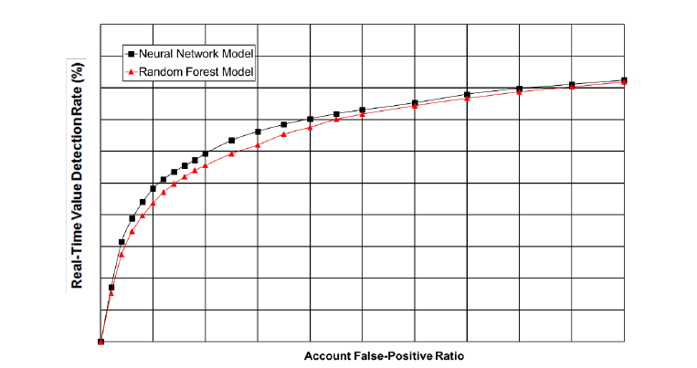

2. The following plots show the performance comparison between a Neural Network model and self-calibrating models on international credit portfolios. Clearly the Neural Network model demonstrates significantly better performance.

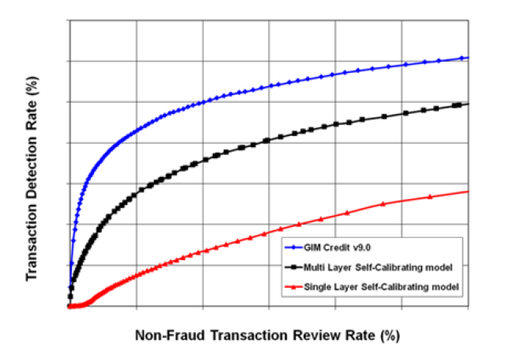

3. FICO compared Neural Networks model with a logistic regression model. While comparing the two models, it was observed that there were significant performance gains using Neural Networks.

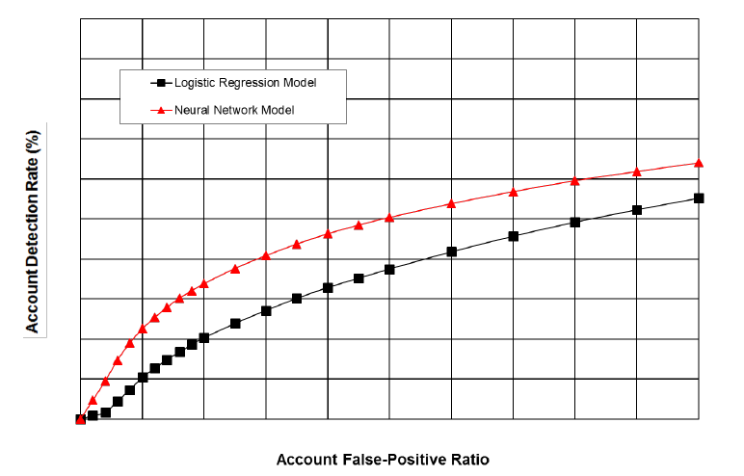

The following results were observed for the US Debit v26 model. The Neural Network model result was compared with a couple of different models to have a comprehensive model comparison.

1. Neural Network model vs Random Forest model. After comparing the models, it was observed that Neural Network model performed better.

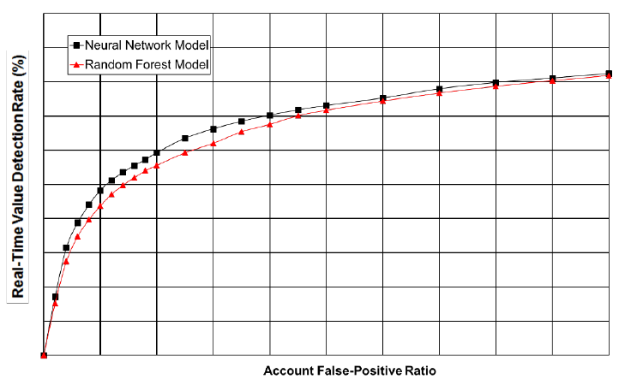

2. The Neural Network model was compared with self-calibrating models on international credit portfolios. The Neural Network model demonstrated significantly better performance.

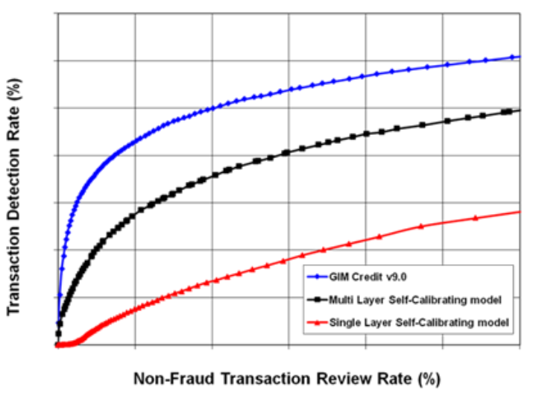

3. FICO compared Neural Networks model with a logistic regression model and observed significant performance gains using Neural Networks.

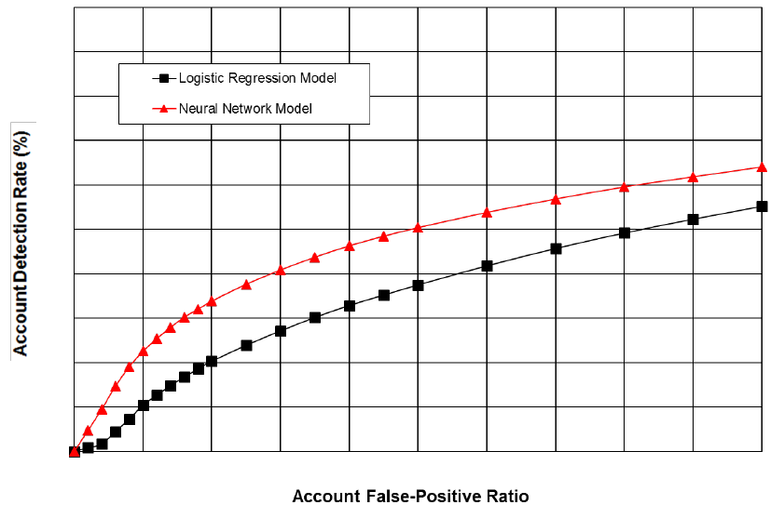

### Sensitivity Analysis

Quantify the impact on model outputs of changes in the value of model inputs and assumptions (e.g., economic inputs, tuning parameters, calculation rules, and scenarios). If the model design is such that the sensitivity of the model output to changes in an individual input would depend significantly on the value of one or more of the other inputs, the impact of simultaneous changes in inputs should also be evaluated.

Model Owner:

Not applicable as SecurLock Predict is a rule-based model. However, the model primarily relies on FICO Falcon’s transaction scoring capabilities, which should be considered while assessing Sensitivity Analysis.

FICO Falcon routinely looks at the sensitivity of model performance to inputs from the data specification, and this is provided internally to the AEG group, who works with model implementation. In context of Credit transactions, FICO has analyzed the performance impact (percentage reduction in ADR and RTVDR at 0.5 Percent Non-Fraud) when the following key fields are blanked out at the specified percentage rates:

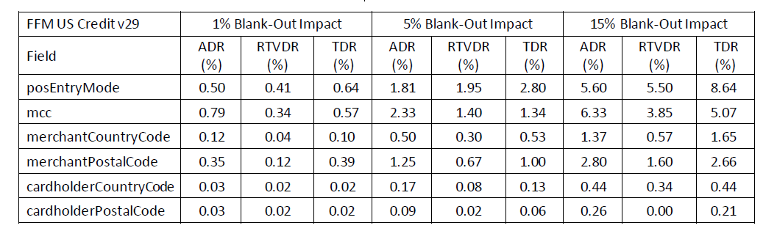

Similarly, In context of Debit Transactions, FICO routinely looks at sensitivity of the internal variables and inputs from the data specification and this is provided internally to the AEG group who works with model implementation. FICO has analyzed the performance impact (percentage reduction in TDR, ADR and RTVDR) when the following key fields are randomly blanked out:

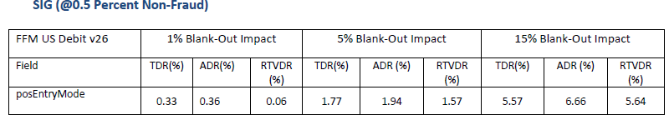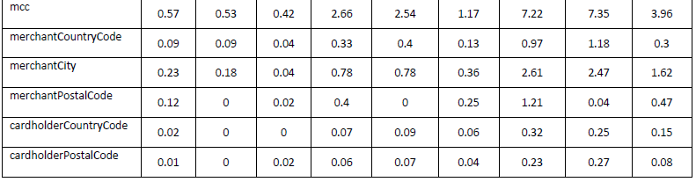



The analysis is a systematic review of model performance based on the varying degrees of data quality. Fields are tested one at a time by blanking out the field for various percentages of the observations. By reviewing the degradation of model performance for each field and each level of missing data, FICO is able to determine which fields are most important to performance. In addition to blank-out analysis, model performance impacts are reviewed for invalid field values to ensure the model robustly handles data discrepancies. For example, FICO has evaluated model performance degradation after increasing the transaction amount by 10% in 15% of the transactions, as summarized in the following table:





Finally, FICO measures the impact to model performance for cases where a client might validly populate a field but without variation – e.g., a numeric field 100% populated with 1.00. All of these tests help FICO support its clients with model performance and data quality inquiries to ensure the model is appropriate for a client’s portfolio.

### Stress Testing / Scenario Analysis

Quantify the impact on model outputs of stressed changes in the values of inputs, including scenarios that are outside the range of ordinary expectations.

For stress testing/CECL/IFRS 9 and other models dependent on economic scenarios, assess the model forecast across benign and stressful scenarios. When evaluating model forecasts under different economic scenarios, the forecasts should be compared to historical values during similar economic conditions (to the extent that such comparison is meaningful). Any notable differences should be explained and justified. For example, if a model produces drastically lower forecasts of losses under a severe stress scenario compared to the historical losses during the Great Recession, an explanation (e.g., notable improvements in the portfolio quality) should be provided and supported with quantitative analysis, where possible.

The forecasts should also be assessed for internal consistency. For example, do the base, adverse, and severely adverse forecasts reflect incremental macroeconomic stress, or, if not, are they consistent with the unique characteristics of the scenarios and business intuition?

For vendor models, stress testing/scenario analysis should be performed on the Company’s internal data. If not feasible, include the model owner’s assessment of the stress testing and scenario analysis provided by vendor (based on vendor’s data) and any associated risks.

Model Owner:

FIS SecurLock Predict operates as a rule-based model, rendering the application of stress testing or scenario analysis irrelevant. Furthermore, FICO Falcon did not provide any data for such analyses.

### Other Testing

Describe other testing performed applicable to the selected modeling approach, **if any**.

Model Owner:

No additional testing has been conducted.

### Overall Performance Assessment

Discuss overall conclusions on model performance based on the results of the testing described above.

Model Owner:

A model is considered to perform well when it achieves high ADR and RTVDR while keeping false positives at an acceptable level. Performance improvement numbers cited below are based on the model validation set.

The following figure shows the relative improvement of the FFM US Credit 29.0 model over the FFM US Credit 28.0 model. At 0.5 Percent Non-Fraud, the relative improvement in ADR is 25.60 percent, and the relative improvement in RTVDR is 11.93 percent.

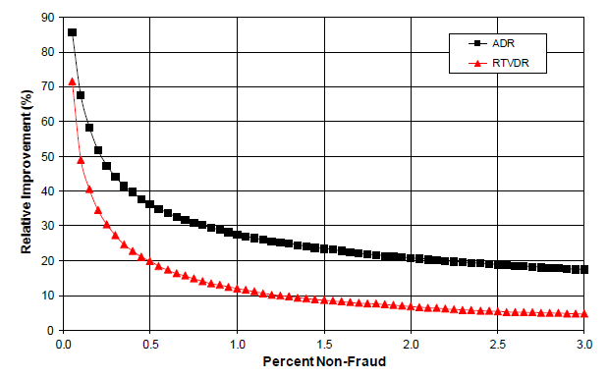

The following figure shows the relative improvement of the FFM US Credit 29.0 model over the FFM US Credit 28.0 model on CNP transactions. At 0.5 Percent Non-Fraud, the relative improvement in ADR is 36.37 percent, and the relative improvement in RTVDR is 19.99 percent.

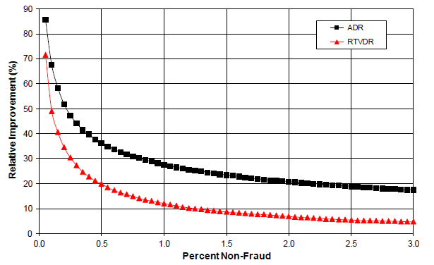

The following figure shows the relative improvement of the FFM US Credit 29.0 model with Adaptive Analytics over the FFM US Credit 29.0 model without Adaptive Analytics. At 0.5 Percent Non-Fraud, the relative improvement in ADR is 1.05 percent, and the relative improvement in RTVDR is 1.60 percent.

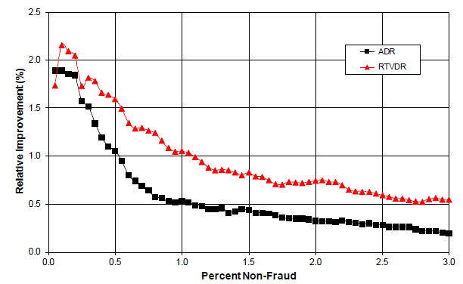

The following figure shows the relative improvement of the FP US Credit 29.0 model over the FP US Credit 28.0 model. At 0.5 Percent Non-Fraud, the relative improvement in ADR is 13.77 percent, and the relative improvement in RTVDR is 13.27 percent.

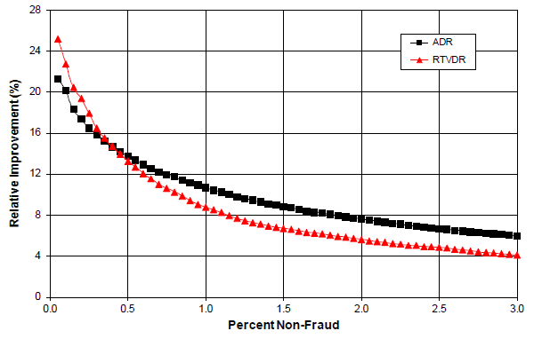

The following figure shows the relative improvement of the FP US Credit 29.0 model over the FP US Credit 28.0 model on CNP transactions. At 0.5 Percent Non-Fraud, the relative improvement in ADR is 18.38 percent, and the relative improvement in RTVDR is 17.85 percent.

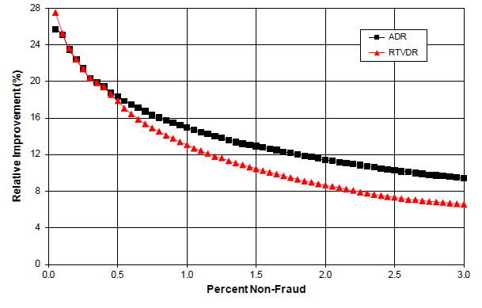

The following figure shows the relative improvement of the FP US Credit 29.0 model with Adaptive Analytics over the FP US Credit 29.0 model without Adaptive Analytics. At 0.5 Percent Non-Fraud, the relative improvement in ADR is 0.35 percent, and the relative improvement in RTVDR is 0.51 percent.

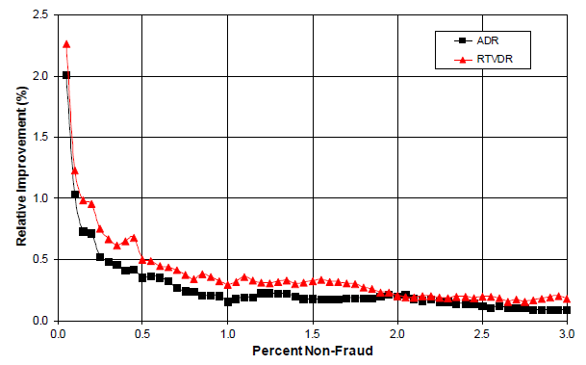

The following figure shows the relative improvement of the FFM US Debit 26.0 model over the FFM US Debit 25.0 model. At 0.5 Percent Non-Fraud, the relative improvement in ADR is 9.88 percent, and the relative improvement in RTVDR is 5.94 percent.

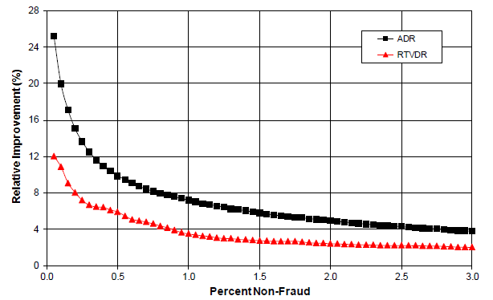

The following figure shows the relative improvement of the FFM US Debit 26.0 model over the FFM US Debit 25.0 model on signature debit card-not-present transactions. At 0.5 Percent Non-Fraud, the relative improvement in ADR is 13.03 percent, and the relative improvement in RTVDR is 7.24 percent for transactions scored in real-time.

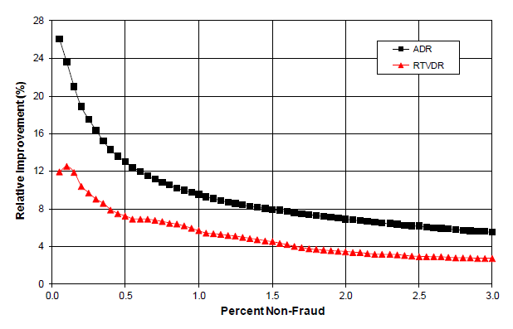

The following figure shows the relative improvement of the FFM US Debit 26.0 model over the FFM US Debit 25.0 model on PIN debit transactions. At 0.5 Percent Non-Fraud, the relative improvement in ADR is 7.82 percent, and the relative improvement in RTVDR is 14.16 percent for transactions scored in real-time.

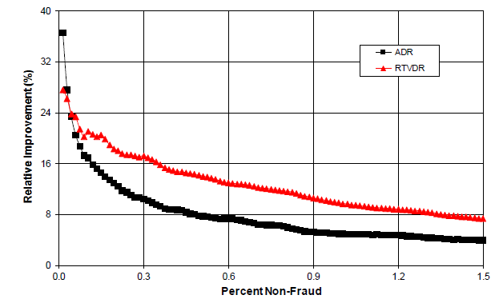

The following figure shows the relative improvement of the FFM US Debit 26.0 model with Global Intelligent Profiles over the FFM US Debit 26.0 model without Global Intelligent Profiles on PIN debit transactions. At 0.5 Percent Non-Fraud, the relative improvement in ADR is 1.67 percent, and the relative improvement in RTVDR is 0.72 percent for transactions scored in real-time. The same results apply to the FP US Debit 26.0 model with Global Intelligent Profiles compared to the FP US Debit 26.0 model without Global Intelligent Profiles on PIN debit transactions.

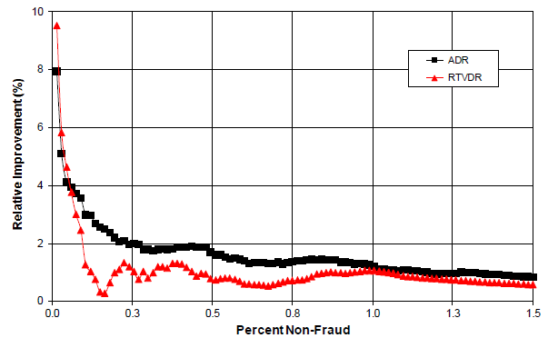

The following figure shows the relative improvement of the FFM US Debit 26.0 model with Adaptive Analytics over the FFM US Debit 26.0 model without Adaptive Analytics. At 0.5 Percent Non-Fraud, the relative improvement in ADR is 1.32 percent, and the relative improvement in RTVDR is 2.20 percent for transactions scored in real-time.

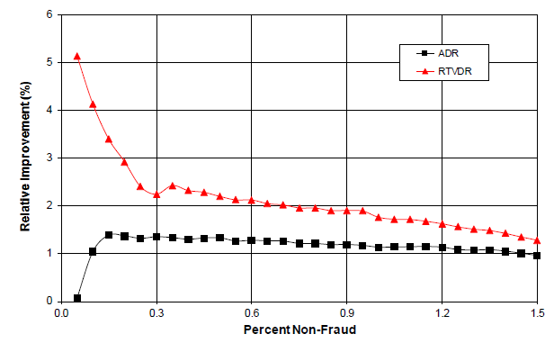

The following figure shows the relative improvement of the FP US Debit 26.0 model over the FP US Debit 25.0 model on signature debit transactions. At 0.5 Percent Non-Fraud, the relative improvement in ADR is 9.01 percent, and the relative improvement in RTVDR is 7.33 percent.

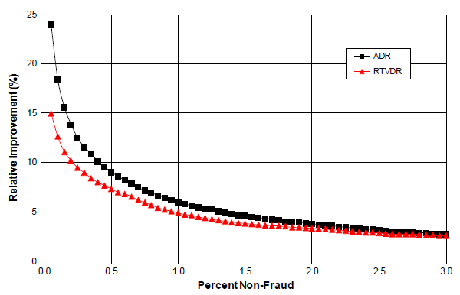

The following figure shows the relative improvement of the FP US Debit 26.0 model over the FP US Debit 25.0 model on signature debit card-not-present transactions. At 0.5 Percent Non-Fraud, the relative improvement in ADR is 12.15 percent, and the relative improvement in RTVDR is 9.60 percent for transactions scored in real-time.

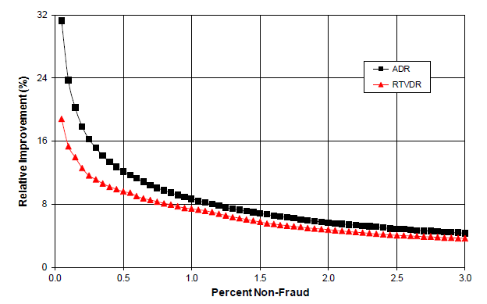

The following figure shows the relative improvement of the FP US Debit 26.0 model with Adaptive Analytics over the FP US Debit 26.0 model without Adaptive Analytics. At 0.5 Percent Non-Fraud, the relative improvement in ADR is 1.00 percent, and the relative improvement in RTVDR is 1.89 percent for transactions scored in real-time.

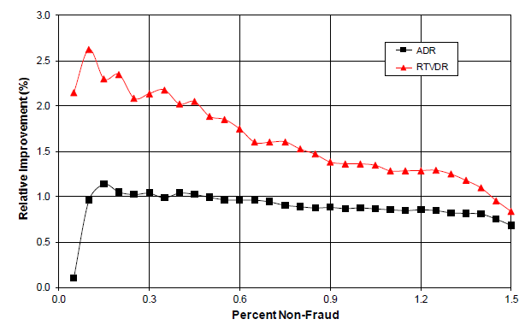

### Need for Model Overlays

Document any proposed or implemented adjustments or overlays to the model outputs and their rationale. Describe the process for derivation and application of these overlays. Provide the impact by including model results with and without these overlays. Finally, outline the overlay review & challenge/approval process, including any Senior Management / Committee reviews and approval process if applicable, and the frequency of the overlay re-evaluation.

For vendor models, discuss the need for model tuning/dialing settings to better align model outputs to the Company’s internal outcomes.

Model Owner:

Since there are no management overrides present in the model, there is no need for model overlays.

If adjustments are made, they will be carefully reviewed, tested, and approved by senior management or relevant committees to ensure they align with the intended goals.

# PRODUCTION PROCESS COMPLETENESS & ACCURACY

This section includes procedures and information related to model testing and usage following model development or vendor model acquisition.

**Reference Document List**

Please list all the documents referred to in this section.

|  |  |  |
| --- | --- | --- |
| **#** | **Reference Document Name** | **High Level Description and purpose of the Document** |
| 1 | f06 MRM-CONTROL01 - y&n Model Assmt Fraud 056 -Charles Lin YesM - SecurLock Predict | This document includes Model vs. Non-Model Assessment Form. |
| 2 | FICO Falcon Model Governance US Credit v29 (v2.0) | Detailed theory, development, and validation of the FICO® Falcon® Fraud Manager. |
| 3 | FICO Falcon Model Governance US Debit v26 (v2.0) | Detailed theory, development, and validation of the FICO® Falcon® Fraud Manager. |
| 4 | MRM-CONTROL02 - Model Inherent Risk Rating Assessment Form v04 - FIS SecurLock Predit | This document includes Model Inherent Risk Rating Assessment Form. |
| 5 | DC Metrics | Summary of Debit Card Metrics. |
| 6 | EWB Jan 2025 SecurLOCK™ Report | Performance monitoring metrics produced by FIS of debit card and credit card. |
| 7 | SecurLOCK Operations Guide | Operations guide of SecurLock and details of fraud alert generation process. |
| 8 | SecurLOCK User Guide 2024 | Users Guide of SecurLock and details of SecurLock servicing. |

# 

## 4.1 Production Application Testing

Describe the testing for accuracy of implementation of the model into production systems.

### 4.1.1 System Testing Approach and Results

The objective of model production application testing is to ensure that computational processes implementing model calculations:

* Are consistent with the documented model specifications produced as part of the model development process. This includes source data fields, data transformation rules, mathematical equations, assumption values, etc.
* Are consistent with the documented business / user requirements.
* Are mathematically accurate and complete.
* Have been reviewed for consistency with any applicable accounting/finance specifications (e.g., GAAP and/or accounting policy requirements), stress testing requirements, or any other applicable regulatory requirements.
* Are operationally stable, repeatable, and sustainable.
* Interface accurately with both upstream and downstream systems (where applicable).

For vendor models, the purpose of the production application testing is to ensure that the models are correctly implemented on the Bank’s systems—if on-premises production process is selected, or the vendor’s model production environment is correctly connected to the Bank’s production data environment—if a cloud-based production process is selected, that the Bank’s production data inputs are consistent with the model publisher’s input specifications, and that all applicable software patches and fixes have been applied.

Describe in detail the testing plan for the individual model’s production implementation and its integration within a larger system and the vendor’s model production environment, if applicable. Include User Accepting Testing cases and scenarios, expected outcomes, and the individuals responsible for executing the test cases.

Document the results of the UAT testing execution, and the associated log of issues and subsequent resolutions.

Model Owner:

**FIS SecurLock Predict is a cloud-based solution. SecurLock Predict is a customized fraud-strategy program that addresses fraud specifics to each issuer’s portfolio. Vendor (FICO Falcon) is responsible for software release and patch management. FIS worked with the bank on data to ensure data consistency with the initial input specifications from the initial implementation.**

**Note**

**• The bank does not maintain any documentation from the initial implementation.**

**• Testing plans are not available.**

### 4.1.2 User Acceptance Testing Approach and Results

Document the User Acceptance Testing approach, results, and sign-offs.

Model Owner:

For User Acceptance Testing, we leverage the FICO Falcon platform to score transactions and assess fraud risk. The UAT process ensures that transaction scores align with the expected fraud detection parameters, confirming the model’s accuracy and effectiveness in real-world scenarios. Results are analyzed to validate that the fraud detection strategies meet the issuer’s portfolio-specific requirements.

Upon implementation of a model, FICO AEG team has a formal process whereby data is to be provided by the client/processor at several time periods such that FICO AEG can validate that the card profiles are maturing appropriately, the input data fields are populated as expected per the development data, and the model score distribution is reasonable with respect to the distribution provided in the model report.

The client/processor provides profile snapshot data and 24 hours of authorizations to FICO Analytics and the analytics team performs data validation comparing the production inputs to the consortium data used in model training. In addition, score distributions are created to ensure the observed production score distribution is similar to the model report. (Note, with individual clients/processors one should not expect perfect alignment with the overall consortium results shown in the model report.) Any discrepancies in input values are discussed with the client/processor and fixes implemented if possible. A typical validation process occurs 4 times on day 1, 8, 15, and 29 post-implementations where day 1 is compared to results from pre-implementation (Day -6).

## 4.2 Model Production Specifications

The following technical specifications should cover the end-to-end operation of the model, from data inputs and assumptions to final model reports. **To avoid duplication of information, some of the following sections may refer to earlier document sections instead of repeating the information.**

### 4.2.1 Model Platform

Describe the technologies used for running the model, for example, Python, R, Excel, etc.

Model Owner:

FIS is a cloud-based solution.

### Data and Process Flow Diagram

Provide a flow diagram showing data sources, inputs, quality assurance control points, intermediate results, outputs, and reports.

Model Owner:

The diagram illustrates the complete process flow of FIS SecurLock, highlighting its upstream dependency on FICO Falcon from the initial stages to the final model output. It includes several essential steps necessary to achieve a valid model output. These steps are as follows:

The process starts with FICO Falcon receiving data from the dedicated data sources i.e. card transaction and the card profile.

The data inputs from the sources include PAN, Transaction Type, Date, Time, Amount, Currency Code, etc.

The data from the input source is then transferred to Quality Assurance (QA) for generating the Data Quality Report (DQR). The DQR is essential to ensure the effectiveness and reliability of fraud detection systems by providing accurate data, which is clean, correct and consistent.

After the DQR is generated and the data quality is marked ok for the required metrics, the data is then processed using the proprietary FICO technology and a score is generated. The score ranges from 1 to 999, with higher scores indicating more chances of fraud.

These risk scores are transferred to FIS SecurLock rule-based system for further processing.

Leveraging the predefined rules within the SecurLock model, each transaction undergoes a comprehensive evaluation process. The system then generates a classification status, categorizing the transaction as either fraudulent or non-fraudulent.

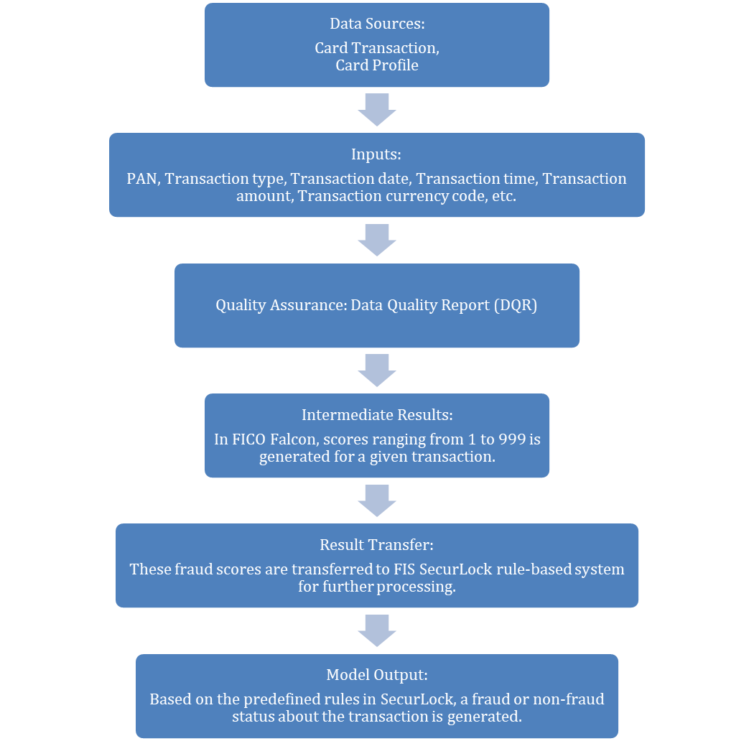

### Input Data Specifications

Provide a list of all inputs, including measurement units, a description of valid values or ranges (a full data dictionary should be attached in an appendix). Describe any data processing rules, such as filtering missing or invalid values infilling / overrides, substituting ceiling or floor values, data transformations, etc.

Model Owner:

The FIS SecurLock Predict program is a customized fraud detection solution that addresses fraud risks specific to each issuer's portfolio. It works in conjunction with FICO Falcon platform to score transactions, evaluating their risk levels while VISA VAA and Mastercard are employed to trigger alerts for potentially compromised transactions. The final decision on whether to approve or decline a transaction is made by SecurLock Predict, leveraging a rule-based system developed in collaboration with East West Bank.

The key input data used to score transactions by FICO Falcon are as follows:

• *PAN*

• *authPostFlag*

• *transactionType*

• *transactionDate*

• *transactionTime*

• *gmtOffset*

• *transactionAmount*

• *transactionCurrencyCode*

Model variables are included based on their statistical significance and benefit to model performance. FICO performs data validation and go-live analysis to indicate if any fields are not present in the customer's data and/or in error based on its knowledge of the key fields that drive model performance. The FICO model does not use the following data: race, ethnicity/color, religion, gender, sexual orientation, gender identity/expression, marital status, familial status, age, national origin, protected veteran status, disability, or receipt of public assistance.

The US Credit v29 model is most sensitive to the following fields and missing or inaccurate data in these fields will impact model performance.

• *postroad*

• *mcc*

• *merchantCountryCode*

• *merchantPostalCode*

• *cardholderCountryCode*

• *cardholderPostalCode*

• *merchantId*

• *merchantCity*

• *terminalId*

On the other hand, the US Debit v26.0 model is most sensitive to the following fields and missing or inaccurate data in these fields will impact model performance.

*• posEntryMode*

*• mcc*

• *cardholderCountryCode*

• *cardholderPostalCode*

*• merchantCity*

*• merchantCountryCode*

*• merchantId*

*• merchantPostalCode*

• *merchantState*

*• terminalId*

• *pinVerifyCode*

• *authPostMiscIndicator*

• *transactionCurrencyConversionRate*

### Model Formulas / Algorithms

Describe detailed model formulas, algorithms, and numerical techniques, if possible.

Model Owner:

The FIS SecurLock Predict program is a customized fraud detection solution that addresses fraud risks specific to each issuer's portfolio. It works in conjunction with FICO Falcon platform to score transactions, evaluating their risk levels while VISA VAA and Mastercard are employed to trigger alerts for potentially compromised transactions. The final decision on whether to approve or decline a transaction is made by SecurLock Predict, leveraging a rule-based system developed in collaboration with East West Bank.

FICO utilizes a proprietary neural net technology called NNET NNET08 for credit transactions and NNET20 for debit transactions which is a tool utilizing back propagation and unique regularization to produce a neural net score that is refined for rare event detection such as payment card fraud. This NNET has been shown repeatedly to outperform other neural net trainers on the market and even FICO's own Model Builder.

In production the weights are fixed and unchanged; this continues to drive the highest performance and is most computationally efficient. The model structure is often single layer with different model segments to minimize the number of degrees of freedom.

The following diagram is a high-level representation of a neural network with a single hidden layer and with the

back propagation of the error. Training typically starts with random weights using back propagation of the errors

to adjust the weights until the network converges.





***Variable Selection***

During model retrain, FICO takes a “kitchen sink” approach to variable selection. Standard statistical techniques

such as stepwise, forward, and backward analysis as well as internally developed methodologies are used in

variable selection. Variables that are no longer predictive from the prior model version are removed and

additional variables are considered.

### Model Parameters and Settings Values

Provide the values for all parameters and other input assumptions, including hyper-parameters for machine learning models.

For vendor models, specify values of user-selectable settings.

Model Owner:

FIS SecurLock Predict program collaborates with the FICO Falcon platform to score transactions and assess their risk levels. Additionally, VISA VAA and Mastercard are used to generate alerts for potentially compromised transactions. The ultimate decision to approve or decline a transaction is made by SecurLock Predict, utilizing a rule-based system developed in partnership with East West Bank.

The client’s portfolio should resemble the statistics of the model development portfolio and should be carefully monitored in terms of score distribution.For FICO Falcon Scores range from 1 to 999. The higher the score, the greater the likelihood is that the account associated with the transaction has been used fraudulently.

In a Falcon model, an issuer sets a threshold score. If a transaction on an account score above this threshold, it is considered suspect enough to be investigated further or referred. Scores above the threshold place the transaction, and thus an account, into one of two groups: actual frauds or false positives; the latter are legitimate accounts that may appear suspected because they do not reflect usual spending patterns.

Few examples of SecurLock Predict ruleset in collaboration with EWB are as follows:

**For Credit Transactions**

**CR_CASE_AA_EWB_THRESHOLD**

**Section One:**

• Fraud Score >= 960

• VAA Score >= 36

• Merchant State NOT CA

• POS Entry Mode NOT Chipped

**For Debit Transactions**

**DB_RT_AA_EWB_THRESHOLD**

**Section One:**

• Country <> 840

• POS Entry Mode <> V

• Fraud Score >= 928

• VAA Score <> Between: 1 – 39

Section Two:

• Country = 840

• POS Entry Mode <> V

• Fraud Score >= 928

• VAA Score <> Between: 1 – 31

Section Three:

• POS Entry Mode = V

• Fraud Score >= 888

• VAA Score >= 48

Section Four:

• VAA Score >= 73

Section Five:

• Fraud Score = 0

• Previous Fraud Score > 895

• VAA Score >= 56

Section Six:

• Fraud Score >= 986

Section Seven:

• Fraud Score = 0

• Previous Fraud Score >= 980

Input Assumption is as follows:

Clients and processors must be able to provide accurate and complete data for the model execution. The client’s portfolio should resemble the statistics of the model development portfolio and should be carefully monitored in terms of score distribution.

In addition, any client’s portfolio should use the model only on those portfolios on which the model was developed with respect to geography, product type, and transaction type.

For more information on SecurLock Predict ruleset, please refer to the following document.



### Model Outputs

Provide a list of all model outputs, including expected values or ranges.

Model Owner:

The FIS SecurLock Predict program is a tailored fraud detection solution designed to address the unique fraud risks of each issuer's portfolio. It collaborates with the FICO Falcon platform to score transactions and assess their risk levels. Additionally, VISA VAA and Mastercard are used to generate alerts for potentially compromised transactions. The ultimate decision to approve or decline a transaction is made by SecurLock Predict, utilizing a rule-based system developed in partnership with East West Bank.

Falcon model run neural-network models that calculate a score each time they are presented with a card transaction. Scores range from 1 to 999. The higher the score, the greater the likelihood is that the account associated with the transaction has been used fraudulently.

The key output is the response that SecurLock Predict returns after interrogating a card transaction, whether the transaction is allowed to proceed or not.

Issuers view the fraud alert generated by FIS SecurLock as:

**1. Other Status (Active, Unable to Confirm, Call Back, etc.)**

These are the most important, as they have not been confirmed by your cardholder.

1. **Confirmed Fraud**

These typically require follow-up action on reissued cards or action to start the fraud chargeback process by the issuer.

1. **Confirmed Not Fraud**

Review these fraud alerts for validated activities in case additional review of the case is warranted.

### Reports

Provide a list of all standard output files or reports and describe how they are used in the business.

Model Owner:

The key output is the response that SecurLock Predict returns after interrogating a card transaction, whether the transaction is allowed to proceed or not. The output impact is ultimately whether the card transaction is allowed or not.

FIS Card Fraud Analytics produces a deck to present monthly for the bank with trends and key metrics for both debit and credit cards. Analytics included Point of Service (POS) Entry Mode for both Card Present (CP) and Card Not Present (CNP). POS entry modes for debit card includes entry via chip, magnetic stripe, contactless card, and E-commerce.

Targeted monitoring conducted by Fraud Strategy team and focused on the Falcon debit card prevention and ledger loss. Below are the SecurLock Predict Debit Card metrics:

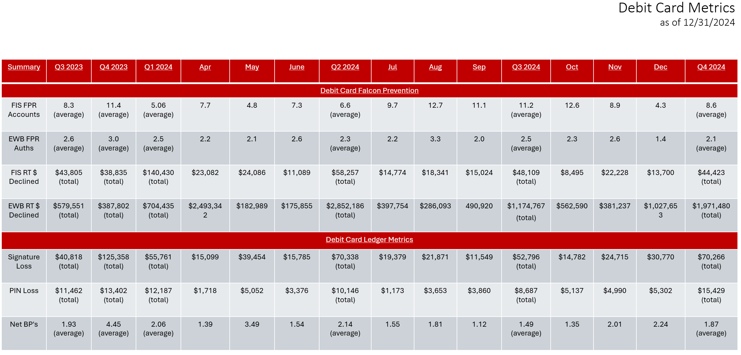

Below are the credit card metrics produced by FIS:

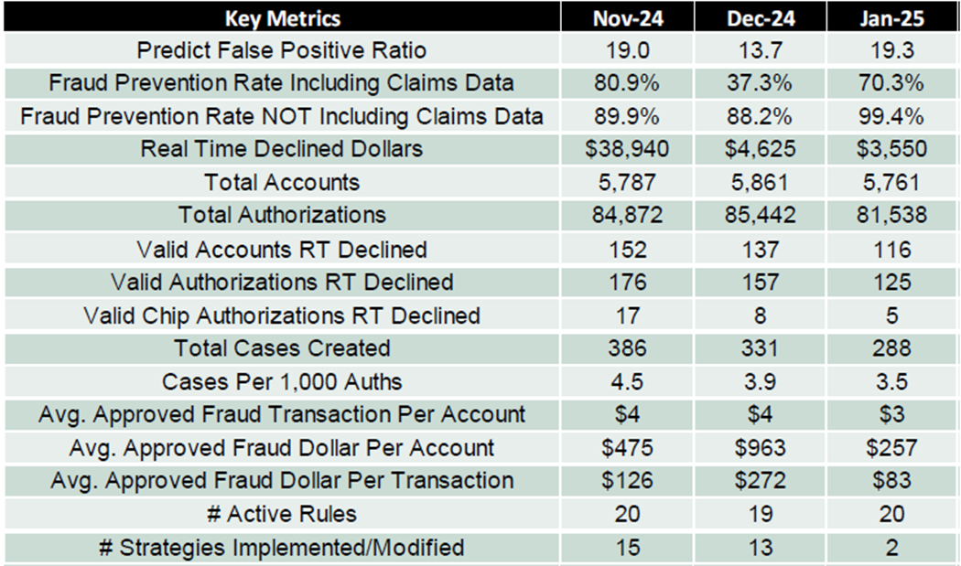

Below are the debit card metrics produced by FIS:

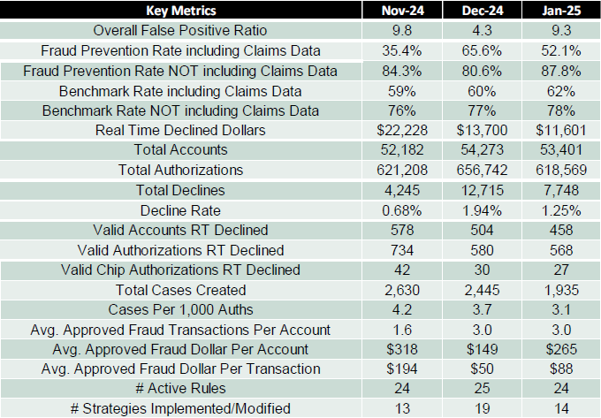

In addition to the aforementioned measures, SecurLock also dispatches a Fraud Alert Detail Report to the bank if they are unable to contact the cardholder. This report is issued under the following conditions:

* A temporary block has been placed on the account.
* No fraudulent activity has been verified.
* Fraud has been confirmed, resulting in a permanent block on the account.
* The cardholder refuses to validate security measures with us, prompting a referral to the issuer.
* Suspicious callers require referral to the Financial Institution for further assistance.

For further information, Please refer to the following documents: 

## Operational Controls

Operational controls related to the model should be in place prior to the production deployment of the model.

### 4.3.1 Model Access and Security

Access controls prevent unauthorized changes to the production code and unauthorized operation of the model in production. Describe who has “write access” to the model and can make changes to the underlying code of the model in development and in production, who has access to run the model in production, and who controls model access rights. If there is a formal access monitoring and review process in place, describe it here. Indicate whether any model files are password protected.

If there is no technical mechanism to prevent changes to the model in production (e.g., if the model is implemented using Python code), describe any checks performed to verify that no unauthorized changes have been made since the last approved update or use of the model (such as code comparisons).

Model Owner:

SecurLock Case Manager is a user interface developed for FIS SecurLock Issuers to provide access to fraud alerts/cases generated by the SecurLock neural network at the time of suspicious cardholder activity. This service allows the ability to update and view details of current fraud alerts/cases (AKA: Case Investigation Sheets) that have been created within the past seven days. This functionality allows Issuers to assist cardholders directly and close the fraud alert with the appropriate No Fraud/Fraud status, eliminating the need to refer a cardholder to contact FIS directly and/or update the bank via the FI IVR or email updates.

Easy-to-use, the SecurLock Case Manager interface allows users to search for fraud cases by Bank Identification Number (BIN), BIN Plan or card number.

### Production Deployment

Describe the production deployment process for the new model or changed model, including related controls.

Model Owner:

SecurLock Predict was implemented for Credit Card in 2017 and implemented for Debit Card in 2018. Both are still active today.

### Model Usage Controls

Describe the controls related to model usage, such as verification of inputs (including reconciliation to the general ledger or other reference data, as applicable), confirmation of successful model execution (e.g., all input records were processed, output values are within valid ranges), completion of hand-offs to downstream users of the model’s outputs, etc.

Model Owner:

The model usage controls involve several key steps to ensure its proper operation. Inputs are carefully verified, with data reconciliation to ensure they match reference data, like the general ledger. Inputs to the model are verified against reference data, such as the general ledger or other authoritative sources, to ensure accuracy and completeness, identifying any discrepancies or errors before execution. After the model is run, a verification process checks that all input records have been processed correctly, ensuring the number of input records matches the processed records and that no records were skipped or duplicated. The output values are validated to ensure they fall within expected ranges, with any anomalies flagged for further investigation. The outputs are then handed off to downstream users or systems in a controlled manner, verifying that they are correctly formatted and complete before proceeding. Successful model execution is confirmed by checking that all input records are processed, and output values fall within expected ranges.

The FIS model is integrated into the organization’s broader fraud detection framework , with a predefined threshold that determines transaction risk levels. These thresholds are periodically reviewed and adjusted based on performance monitoring and evolving fraud patterns.

However, specific details regarding the control and management of usage control are unknown.

Additionally, there are no downstream users of the model, making it challenging to define specific control mechanisms.

### Model Backup

Provide the model backup procedures, including parties involved and frequency, and describe how the model owner has determined that the procedures are functioning correctly.

Model Owner:

The data centers for the FIS models are separated into different geographies. This separation ensures that a disaster affecting one location will not impact the other, providing robust disaster resilience. External business continuity or disaster recovery (BC/DR) service providers are not utilized for data center recovery needs, as the alternate facility is equipped with equal processing capacity to the primary facility, ensuring seamless operations.

In the event of a disaster, the backup facility is capable of sustaining operations for an extended period, at least six weeks, without compromising performance. For work area recovery, geographic separation is maintained between the production work site and the recovery site, further enhancing disaster preparedness.

To ensure the effectiveness of the backup plan, regular disaster recovery drills are conducted, ensuring both data centers are fully operational and capable of handling the load during a disaster. Continuous data synchronization between different data centers is maintained to minimize data loss.

A comprehensive communication plan is in place to inform all stakeholders promptly in the event of a switch to the backup facility. Detailed documentation of all procedures and protocols related to disaster recovery and backup operations is meticulously maintained. Regular reviews and updates of the backup plan are conducted to address any changes in infrastructure, technology, or business processes.

## Contingency Plans

### Disaster Recovery Plan

Provide a reference to the disaster recovery plan or describe the plan here.

Model Owner:

**Purpose**

The purpose of this Disaster Recovery Plan (DRP) is to guide East West Bank (EWB) personnel through the steps necessary to recover the relevant application from a disruption or data center impacting incident. This plan will be activated based on the type and severity of the disruption as determined by management and may be used individually or in conjunction with other DR/BC plans throughout the organization.

**Assumptions**

The following assumptions were used when developing this plan:

• The application is inoperable in its primary data center.

• Key personnel have been identified and trained in roles and responsibilities related to disaster recovery.

• Application recovery activities may occur following application disruption and troubleshooting, but final failover or setting up the recovered instance as the primary application will not occur without leadership approval.

**Communication**

Application issues can be reported by the EWB Helpdesk, Network Operations Center (NOC)monitoring, or escalations to the Recovery Team. Possible outages are reported by users to the NOC Team immediately by calling 855-228-8815. Once a possible outage has been identified, the NOC Team will set up an investigative IT Response Call with the Recovery Team to validate and troubleshoot the issue.

If efforts to resolve the application disruption are unsuccessful, the Recovery Team will either manage the outage and required reports for EWB hosted applications or contact the application vendor to report the outage for vendor hosted applications. The Recovery Team can activate the Disaster Recovery Plan for the affected application immediately with no minimum downtime requirement. The NOC Team will communicate the status of the application to the EBCO team for visibility and additional support.

The NOC will send out regular status updates via email to all DRP and EBCO contacts throughout the application recovery process.

**Escalation**

In case of significant downtime or severe disruption, the Enterprise Business Continuity Office will activate the Enterprise Crisis Management Plan.

**Application Overview**

FIS SecurLock Predict is a heuristic neural network software for credit, debit, and prepaid fraud detection. It scores transactions for fraud likelihood using global and portfolio-specific metrics. The suite includes a transaction monitoring system and case management component.

**Key Recovery Processes**

Recovery Team Responsible for coordinating and recovering the application in collaboration with the application vendor.

**• Recovery Team Communication**

Communication channels include:

Microsoft Teams or Zoom meetings. Other options like conference calls or in-person meetings.

**• Technical Validation Procedures in DR Environment**

These are the tasks to perform the technical validation of this application once it has been recovered in the DR environment and prepare it for business validation testing.

**• Business Unit Validation Procedures in DR Environment**

This section of the plan includes the process and methods of how the business will verify that the application is operating appropriately within the DR environment and within data loss tolerances.

**Procedures to Return to Business as Usual (BAU)**

**Technical Steps to BAU**

Transition the application from the DR environment to the primary data center without introducing security risks or unexpected downtime. Includes communication plans to inform end-users about the migration.

**• Technical Validation in Primary Data Center**

Post-migration system checks to ensure accurate processing and restore data integrity.

**• Business Unit Validation in Primary Data Center**

Business teams confirm the application’s appropriate functionality and adherence to data loss tolerances post-return to the primary data center.

Refer to the following document for further information related to the Disaster Recovery Plan.



### Business Continuity Plan

Provide a reference to the business continuity plan or describe the plan here. For a vendor model, provide the plan for how the model will be supported or replaced if the external vendor is no longer available to support the model or the vendor’s level of service is unsatisfactory.

Model Owner:

This Business Continuity Plan (BCP) outlines the procedures and protocols to ensure the timely recovery and continued operation of the FIS SecurLock / Falcon Fraud Manager in the event of an unexpected disruption. The plan focuses on minimizing downtime, protecting data integrity, and restoring normal operations efficiently.

**Application Overview**

**Name:** FIS SecurLock / Falcon Fraud Manager

**Description:** FIS SecurLock Predict is a heuristic neural network software solution for detecting fraud in credit, debit, and prepaid transactions. It evaluates transactions globally and at the portfolio level, assigning a fraud likelihood score based on industry models and cardholder-specific metrics. The software suite includes a case management component.

**Escalation Protocol**

The Enterprise Business Continuity Office will activate the Enterprise Crisis Management Plan based on the severity of the disruption and the elapsed downtime.

**Recovery Team**

The Recovery Team is tasked with:

1. Coordinating with the application vendor for recovery.

2. Executing recovery procedures as per the defined playbook.

**Communication Methods:**

1. Microsoft Teams Meeting (generated at the time of the event).

2. Zoom Meeting (generated at the time of the event).

3. Other methods: Conference call or in-person meetings.

**Disaster Recovery Procedures**

**Technical Steps for Recovery in DR Environment**

1. Execute the predefined procedures for application failover, restart, or recovery.

2. Document all recovery activities, including assigned roles and estimated durations.

**• Technical Validation in DR Environment**

1. Perform system checks to ensure the application operates accurately.

2. Verify data restoration meets defined expectations.

3. Prepare the system for business validation testing.

**• Business Unit Validation in DR Environment**

1. Business units verify application functionality and data integrity.

2. Conduct validation tasks specific to each department.

3. Roles and timelines for each validation activity.

**Procedures to Return to Business as Usual (BAU)**

**Technical Steps to BAU**

Transition the application from the DR environment to the primary data center without introducing security risks or unexpected downtime. Includes communication plans to inform end-users about the migration.

**• Technical Validation in Primary Data Center**

1. Perform system checks to confirm the application’s functionality and data integrity post-transition.

2. Validate that all processing is complete and accurate.

**• Business Unit Validation in Primary Data Center**

1. Business units ensure the application is functioning as expected within data loss tolerances.

2. Conduct department-specific validation tasks to confirm full operational readiness.

## Operating Procedures / User’s Guide

Provide step-by-step procedures for running the model, which may include:

1. Input data extraction and preparation, including data cleaning and transformations.
2. Checking the correctness of input data.
3. Setting/updating/checking model settings, assumptions, and parameter values.
4. Checking the correctness of the settings, assumptions, and parameter values.
5. Initiating the processing component of the model.
6. Checking successful completion of the model execution.
7. Extracting model outputs.
8. Checking that model outputs are valid.
9. Producing standard reports.
10. Distributing standard reports.

Note: if there is a separate operating procedural document (or User’s Guide), please list the document name below and share the document with MRM.

Model Owner:

FIS® SecurLock™ is a comprehensive card fraud management solution that integrates the FICO® Falcon® platform to enhance its fraud detection and prevention capabilities. It works in conjunction with FICO Falcon platform to score transactions, evaluating their risk levels while VISA VAA and Mastercard are employed to trigger alerts for potentially compromised transactions. The final decision on whether to approve or decline a transaction is made by SecurLock Predict, leveraging a rule based system developed in collaboration with East West Bank

The key input data from an EWB perspective is the card transaction details. FICO utilizes a proprietary neural net technology called NNET08 which is a tool utilizing back propagation and unique regularization to produce a neural net score that is refined for rare event detection such as payment card fraud.

Model variables are included based on their statistical significance and benefit to model performance. FICO performs data validation and go-live analysis to indicate if any fields are not present in the customer's data and/or in error based on its knowledge of the key fields that drive model performance.

The following fields are required for scoring:

• *PAN*

• *authPostFlag*

• *transactionType*

• *transactionDate*

• *transactionTime*

• *gmtOffset*

• *transactionAmount*

• *transactionCurrencyCode*

The FICO model does not use the following data: race, ethnicity/color, religion, gender, sexual orientation, gender identity/expression, marital status, familial status, age, national origin, protected veteran status, disability, or receipt of public assistance.

During the data build prior to model development, a data quality report (DQR) is produced to validate that the

modeling data is consistent with production data. The validation is performed with respect to the presence of

required data, valid values, percentage of records with populated values, and appropriate product type and

population.

Raw data is continuously cleansed and fixed based on previously agreed conditions with the client and modeling team. Once cleansed,

• The fixed data is inventoried for the coverage period for a particular model build.

• Fraud data for the coverage period is prepared first and checked for completeness.

• The transaction and demographic data are sampled using 100% of the fraud accounts in the fraud file and a sample of the non-fraud accounts.

• Field level and other statistics are gathered on the sampled data.

• File intersection and integrity checks are performed on the sampled data.

• The data is handed over to the modeling team for final quality and validation.

***Missing Value Handling***

Assuming the data in question are required for model scoring, FICO uses various methods to interpolate the value for the missing data for any given observation. FICO utilizes the following methods for missing data: for categorical values FICO may use a 'missing' or 'default' value typically determined using the population frequency distribution. For non-categorical fields FICO models often default to the population mean value.

**Target Variable Construction**

The target variable is constructed using confirmed fraud tags provided by FICO clients as part of the consortium data contribution. Creation of the target variable requires at least one approved fraudulent transaction. The *date-of-first fraud* is either provided by the client or derived based on the dates of confirmed fraudulent transactions. The *block-date* is defined as the transaction date of the last approved transaction following the *date-of-first fraud.*

**Transaction- or Account-Level Target Variable**

For each fraud account, FICO identifies a fraud window, starting with the date-of-first fraud and ending with the block-date. Transactions within a fraud window that match to reported confirmed fraud transactions are tagged as fraudulent for model training. Additional transactions within fraud windows may also be tagged as fraud for model training purposes in some cases. False positives are only tracked on non-fraud accounts, i.e., accounts that have no fraudulent transactions. Therefore, for fraud accounts, non-fraud transactions occurring prior to and after the fraud window are excluded from model training and evaluation. Since models are primarily developed on a transaction-level fraud tag, fraud detection metrics used in model evaluation only consider scores on transactions that match reported confirmed frauds.

Falcon model run neural-network models that calculate a score each time they are presented with a card transaction. Scores range from 1 to 999. The higher the score, the greater the likelihood is that the account associated with the transaction has been used fraudulently.

The key output is the response that SecurLock Predict returns after interrogating a card transaction, whether the transaction is allowed to proceed or not.

SecurLock also dispatches a Fraud Alert Detail Report to the bank if they are unable to contact the cardholder. This report is issued under the following conditions:

* A temporary block has been placed on the account.
* No fraudulent activity has been verified.
* Fraud has been confirmed, resulting in a permanent block on the account.
* The cardholder refuses to validate security measures with us, prompting a referral to the issuer.
* Suspicious callers require referral to the Financial Institution for further assistance.

For further clarity, please refer to the User Guide document attached below:



# ONGOING MODEL GOVERNANCE & OUTCOME ANALYSIS

**Reference Document List**

Please list all the documents referred to in this section.

|  |  |  |
| --- | --- | --- |
| **#** | **Reference Document Name** | **High Level Description and purpose of the Document** |
| 1 | f06 MRM-CONTROL01 - y&n Model Assmt Fraud 056 -Charles Lin YesM - SecurLock Predict | This document includes Model vs. Non-Model Assessment Form. |
| 2 | FICO Falcon Model Governance US Credit v29 (v2.0) | Detailed theory, development, and validation of the FICO® Falcon® Fraud Manager. |
| 3 | FICO Falcon Model Governance US Debit v26 (v2.0) | Detailed theory, development, and validation of the FICO® Falcon® Fraud Manager. |
| 4 | MRM-CONTROL02 - Model Inherent Risk Rating Assessment Form v04 - FIS SecurLock Predit | This document includes Model Inherent Risk Rating Assessment Form. |
| 5 | DC Metrics | Summary of Debit Card Metrics. |
| 6 | EWB Jan 2025 SecurLOCK™ Report | Performance monitoring metrics produced by FIS of debit card and credit card. |

## Ongoing Risk & Performance Monitoring Plan

**Part 1** - provide an overview of the performance monitoring process, including:

1. Frequency of monitoring activities.
2. Titles/positions of individuals/teams responsible for executing performance monitoring analyses.
3. Individuals responsible for evaluating the resulting reports and documenting conclusions.
4. Stakeholders responsible for reviewing the performance reports and initiating required actions in the event that new risks or performance weaknesses are detected.

**Part 2** - provide the details of the **ongoing risk and performance monitoring plan (together, ongoing monitoring plan)** for this model. Ongoing monitoring plans should generally cover the following two types of periodic monitoring activities:

1. Model Risk Monitoring – Reassessment of the model’s risk profile. This includes but is not limited to reassessment of model weaknesses and limitations, as well as the associated risk mitigants in light of any changes in the model use, Company’s strategy, market conditions, and regulatory environment, among other things.
2. Model Performance Monitoring – Analysis of the model’s **predictive performance** and **identification of emerging model performance weakness**.

Specifically, for Model Performance Monitoring design, it is expected that all models should have some type of outcomes-based performance monitoring process in place to evaluate whether the model is meetings its designed objectives. The Model Owners must specify, as appropriate and feasible for the specific model and its individual uses, detailed plans to monitor model performance through **some combination of the following** four methods:

* Comparison of predicted outcomes to actual values (i.e., back-testing).
* Benchmarking model outputs against comparable external data points, such as observable market information, or outputs of alternative models.
* Analysis of sensitivity of model outputs to variations in model inputs, parameters, and assumptions.
* Stress testing of model predictions to extreme changes in model inputs and assumptions.

The Model Owner should define performance thresholds which, if breached, would require the Model Owner to take corresponding actions. Performance thresholds may be set based on business unit policies or procedures, judgmentally, or based on statistical methodology utilizing model performance over the development sample. In all cases, the approach for setting performance thresholds should be established during development and documented in this section.

**Guidelines** for Risk & Performance Monitoring Plan details:

* Risk Monitoring Plan Details: The risk monitoring plan should list the internal and external factors that should be considered when evaluating model risks. This may include, as applicable:
  + - * Changes in the model use.
      * Changes in the portfolio composition or characteristics of the portfolio/asset/liability/transactions to which the model is being applied.
      * Changes in the Company's strategy.
      * Industry and economic environment changes.
      * Regulatory environment changes.
      * New regulatory findings, independent model validation findings, internal audit findings, external audit findings etc. The plan should include a list of internal and external stakeholders, groups, and committees that may identify, either directly or indirectly, model-related risks through their own “ordinary course of business” activities. It is expected that the Model Owner will establish and maintain periodic communications with these stakeholders to monitor emerging risks.
    - Performance Monitoring Plan Details: The performance monitoring plan should include:
* The source(s) of data used in the performance monitoring process.
* The list of key performance metrics that will be calculated and reported along with their technical specifications.
* Description of the performance analysis that will be performed consistent with the requirements.
* Acceptable performance thresholds for each key metric, if applicable. If a specific threshold is not defined, the Model Owners should document the justification for the lack of threshold. The Model Owners’ rationale for selecting particular performance thresholds must be adequately documented. If, as is sometimes the case, an oversight committee is required by the Business Unit/Line of Business to approve model performance thresholds, then this fact must be reflected in the monitoring plan and the Model Owners must retain evidence of such approvals. Finally, the frequency of the re-evaluation of the performance thresholds should be documented.
* Procedures for communicating and escalating performance issues to appropriate stakeholders (committees, upper management, etc.).
* Procedures for responding to performance threshold breaches.
* The list of stakeholders (individuals and committees) responsible for the review of the risk and performance reports.

Part 1 – Overview

|  |  |
| --- | --- |
| Frequency of monitoring activities (e.g., monthly, quarterly, etc.) | Quarterly |
| Titles/positions of individuals/teams responsible for executing performance monitoring analyses | Fraud Strategy, in collaboration with Enterprise Risk Management |
| Individuals responsible for evaluating the resulting reports and documenting conclusions | Fraud Strategy, in collaboration with Enterprise Risk Management |
| Stakeholders responsible for reviewing the performance reports and initiating required actions in the event that new risks or performance weaknesses are detected | Senior Management of Risk and Operations (R&O) |

Part 2 – Risk & Performance Monitoring Plan

Model Risk Monitoring Plan Details:

Model Owner:

FICO invests considerable time following model implementation to ensure the input data, profile variables, and model score distributions are within expectations. Regular assessments help detect any deviations beyond expected performance thresholds. Model updates are recommended annually, and if significant performance degradation occurs, FICO will investigate and provide necessary updates through model service patches for consortium clients.

Model Performance Monitoring Plan Details:

Model Owner:

The performance of the model can be monitored in two ways-

The initial plan pertains to EWB's quarterly monitoring, encompassing metrics such as the False Positive Rate (FPR) and Real-Time Dollar Declined. The subsequent plan involves the vendor's monitoring strategy, which evaluates metrics including the FPR ratio, Fraud Prevention Rate, Average Approved Transactions per Account, and Valid Accounts Real-Time Declined on a monthly basis.

**EWB Performance Monitoring**

**Source of Data Used in the Performance Monitoring Process**

The data used in this analysis is sourced from the internal records of EWB. This data will be subject to periodic checks for completeness and accuracy.

**Monitoring Frequency**

The model’s performance will be subject to periodic review, with monitoring intervals set quarterly, based on the model’s risk profile and operational requirements.

Below are the SecurLock Predict Debit Card metrics produced by EWB Fraud Strategy team.

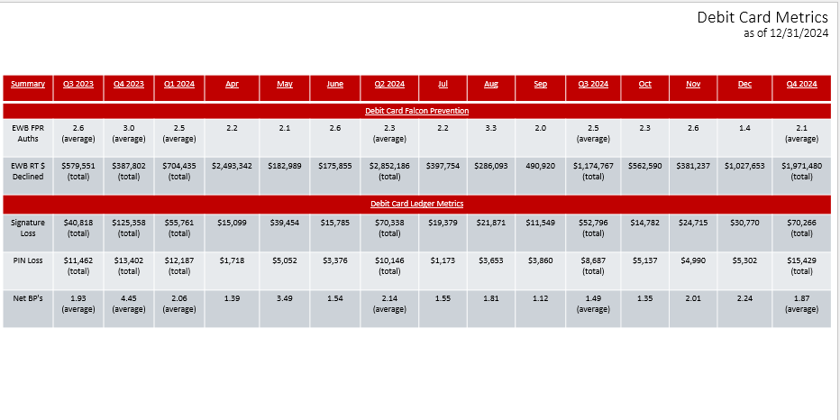

**Parameter and its Methodology**

The **False Positive Ratio (FPR)** expresses the number of accounts identified incorrectly as fraudulent for each actual fraud account the model identifies. In other words, this ratio evaluates how many legitimate cardholder transactions are being declined to capture one fraudulent transaction.

For instance, a false positive ratio of 20:1 indicates that for each genuinely fraudulent account that it finds, a model identifies 20 innocent accounts as fraudulent. So, 100 Not Fraud (VALID)/ 5 Confirmed Frauds (FRAUD) = 20 FPR (False Positive Ratio) – Declined around 20 valid cardholders to capture 1 fraud account.

As the threshold score increases, the false-positive ratio decreases. However, setting a higher threshold reduces the number of actual frauds detected.

The **Real Time Dollar Declined** expresses the total dollar amount of transactions that were declined in real-time due to suspected fraud.

**Thresholds**

Considering Bank’s Performance Monitoring Plan and *Visa 2023 U.S. VAA Model Documentation*shared, AFPR performance threshold selected as **10**.

As the threshold score increases, the false-positive ratio decreases. However, setting a higher threshold reduces the number of actual frauds detected.

**Rationale for This Threshold**

For understanding industrywide measures of False Positive,” **Visa 2023 U.S. VAA Model Documentation” (Page 34),** document from VISA also suggest that ideal False Positive should be 10:1 in fraud detection.

**FIS Performance Monitoring**

**Source of Data Used and Monitoring frequency.**

We have comprehensive performance monitoring metrics in place to track key metrics and ensure effective oversight. The vendor calculates debit and credit card metrics on a monthly basis.

Below are **the SecurLock Predict Credit Card metrics** produced by FIS:

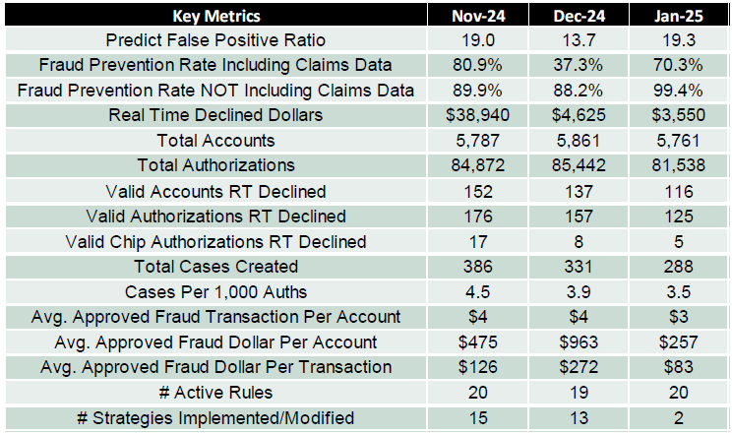

**Parameter and its Methodology**

**Fraud Prevention Rate (Including Claims Data):** The percentage of fraudulent transactions successfully prevented by the model, calculated by comparing the number of blocked fraudulent transactions to total fraud attempts, including transactions that were later confirmed as fraudulent through customer claims.

**Fraud Prevention Rate (Not Including Claims Data):** The percentage of fraudulent transactions successfully blocked by the model, measured against total fraud attempts but excluding transactions that were later identified as fraudulent through customer claims.

**Valid Accounts Real-Time Declined:** The number of legitimate customer accounts that experienced real-time transaction declines due to suspected fraud, despite being valid and non-fraudulent.

**Valid Authorizations Real-Time Declined**: The number of legitimate transactions that were declined in real-time by the fraud prevention model, even though they were authorized and not fraudulent.

**Average Approved Fraud Transactions per Account:** The average number of fraudulent transactions that were incorrectly approved per customer account, indicating the model’s effectiveness in preventing unauthorized transactions.

Below are the **SecurLock Predict Credit Debit metrics** produced by FIS:



**Parameter and its Methodology (additional to the Credit card metrics)**

**Benchmark Rate (Including Claims Data):** The benchmark fraud rate that serves as a performance standard, calculated by considering both real-time fraud prevention data and post-transaction fraud claims. This rate helps assess the effectiveness of the fraud prevention model in identifying fraudulent activity, including cases detected through customer disputes and chargebacks.

**Benchmark Rate (Not Including Claims Data):** The benchmark fraud rate based solely on real-time fraud detection, excluding fraud cases identified through customer claims. This metric provides insight into the model’s initial fraud detection capability without adjustments for post-transaction fraud identification.

**Decline Rate:** The percentage of total transactions that are declined by the fraud prevention model due to suspected fraudulent activity. It is a key indicator of how aggressively the model is filtering potential fraud, balancing fraud prevention with customer experience.

**Cadence with the vendor**

Cadence with the vendor is regular interactions and activities that will help manage and maintain the ongoing performance monitoring, this includes:

• **Regular Meetings:** Quarterly check-ins, to discuss performance and address issues.

• **Performance Reviews:** Monthly evaluations or reviews, to assess the vendor’s performance against agreed-upon metrics and standards.

• **Reporting:** Monthly submission of performance reports, to keep both parties informed about progress and potential concerns.

Establishing a clear cadence with your vendor helps ensure transparency, accountability, and continuous improvement in the partnership. It allows both parties to stay aligned, address issues promptly.

## Model Approval and Change Management Process

In this section, discuss the aspects of the model approval and change management process that are specific to this model.

### Model Approval Process

Provide the names of the individuals (or a committee) involved in the approval process for this model.

Model Owner:

FIS SecurLock Predict is a vendor model, not bank owned. The model is built on shared fraud intelligence of FIS SecurLock Predict and FICO Falcon Fraud Platform. The model is built on FICO Falcon fraud platform. The Fraud Strategy Team works with FIS Risk Office to monitor rule performance and ongoing cadence on the fraud patterns and changes. FIS communicates and recommendes rule changes to the implement for the bank, however bank does have direct control of the production change.

### Model Change Log

Provide a reference to the model Change Log. Please refer to the Bank’s 1st Line Model Risk Management Guidelines (MRM-PnP05), the MRM Procedure (MRM-PnP02), and Model Change Log Template v01.docx for detailed requirements.

Model Owner:

Presently, no change has been associated with this model to log into the MRM change log template.

Adopted the MRM model change log template to capture the nature model changes, reasons for the model changes, and potential model impacts. Using this model change log template to ensure modifications are managed in a framework, minimizing risks, maintaining model integrity to align with MRM quarterly model change certification process. Added risk impact column in the log to provide transparency in the potential impacts.

|  |  |  |  |  |  |  |  |
| --- | --- | --- | --- | --- | --- | --- | --- |
| **Change Date** | **High-Level Description of Change** | **Change Impact** | **Category of Change** | **Responsible Party** | **Supporting Documents & Location** | **Communication and Approval** | **Additional Comments** |
|  |  |  |  |  |  |  |  |
|  |  |  |  |  |  |  |  |

The proposed changes are prompted by changes in fraud patterns, inherent risks, regulatory requirements, business strategies or technical advancements. Each category of change will have different levels of model risk impact.

**Frequency of Model Updates**

As a result of changing fraud behaviors and economic conditions, model performance naturally degrades over time. To address degradation, Falcon models are updated on an annual basis. Those model updates are complete version upgrades (i.e., version *n* to *n+1*). On rare occasions, patches are required to address model release issues. These sub-versions (i.e., version *n.0* to *n.1*) are released as needed.

Full version upgrades are accompanied by a model report similar to *MR_FFM_FP_US_Credit29.0_Falcon6.x.pdf.* Sub-versions may or may not have additional release notes depending on the complexity of the change and potential operational impacts.

**Underlying Cause of Model Improvement**

During model retrain, FICO takes a “kitchen sink” approach to variable selection. Variables that are no longer predictive from the prior model version are removed and additional variables are considered. The US Credit v29 model was retrained on new Fraud and Non-fraud data from the entire US Credit consortium. The model performance benefits from the inclusion of the whole consortium.

Generally, about half of the model of improvement from a retraining exercise can be attributed to the use of new Fraud and Non-Fraud data and the remainder due to the addition of new explanatory variables.

The FFM US Credit 29.0 model has been designed to ensure smooth upgrades from the FFM US Credit 28.0 model. The FFM US Credit 29.0 model adjusts existing card profiles prior to scoring the associated accounts for the first time. The adjustments to existing card profiles minimize, but do not eliminate, some variations in the Falcon scores, which settle out as the card profiles completely mature with the new model.

# APPENDICES

## Appendix A

List and describe references to additional model-related files that have not already been referenced in the Template.

1. “FIS SecurLock Predict - Card Fraud”: Provide information about FICO model and software versions.
2. *“Falcon_Fraud_Manager_1247ps_EN (1)”: Details of FICO Falcon Fraud Manager*
3. *“SecurLOCK Communicate Text and Email Sample 2024”: Communication procedure when fraud alert is generated.*

Model Owner:

All additional model-related files are referenced within the above sections and provided as supporting artifacts to this document.

## Appendix B

For vendor models, provide high level description of the vendor company background, qualifications, and services provided, especially relating to EWB’s purchase. In addition, please reference MRM procedure MRM-PnP04, MRM-PnP04 EWBC MRM Vendor Model Onboarding Process v01.pdf, for detailed onboarding and documentation requirements.

Model Owner:

FIS SecurLock Predict was implemented for Credit Card in 2017 and implemented for Debit Card in 2018. The vendor was vetted through Third Party Risk Management (TPRM) Risk Assessment, see Vendor Management System (VMS) for responses (VMS - Vendor Detail (ewbc.net).